**Olympics**

Presented for  
Enterprises Data Management  
University of Arizona

**Table of Contents**

Chapter 1: Requirements Analysis 3

Chapter 2: Conceptual Schema 7

Chapter 3 17

Relational Schema 17

Chapter 4 37

Queries 37

Query 1 37

Query 2: 39

Query 3: 40

Query 4: 41

Query 5: 42

Query 6 : 43

Query 7: 44

Query 8 45

Query 9: 46

Query 10: 47

Query 11: 48

Query 13 50

Query 14 51

Query 15 52

Query 16 53

Triggers and Procedures 55

Trigger 1 55

Trigger 2 56

Procedure 1 58

Procedure 2 59

User Interface 61

Implementation Plan 78

# Chapter 1

## **1.1 Requirements Analysis**

The International Olympic Datastore (IODS) is envisioned to be a centralized data repository designed to capture, manage, and disseminate comprehensive information across all facets of the Olympic Games. This datastore is crucial for the seamless execution and historical archiving of the events, participants, and associated activities.

The heart of the IODS is the athlete management system, capturing detailed information about athletes, comprising attributes like their names (broken into first and last), date of birth, age, nationalities, genders, and physical attributes like height and weight. Each athlete is uniquely identified by an athlete ID. Furthermore, athletes are closely affiliated with their sports, and can be categorized as individual and team-focused based on the events they engage in during the Olympics.

Coaches have distinct Coach IDs and have features like their name, dates of birth, gender, and nationalities. These mentors may have different specializations relating to the sport they coach. Coaches play an integral role in enhancing an athlete's performance by leveraging the insights from Performance Details, which encapsulates information about an athlete's progress over time, mapped using various performance metrics. The athletes’ performance metrics such as speed (in mph), techniques, performance gains, and medal are recorded.

Editions of the Olympics represent unique instances of the Games, and a set of attributes distinguishes each, the year it was held, and the host city, host country and type of Olympic event. Athletes take part in Olympic editions. Each edition is determined by a unique edition ID. To further enhance the Olympic experience, each edition is associated with Olympic Villages where the events and ceremonies occur. Additionally, village names, amenities, capacity, the level of security and postal address are meticulously defined for each Olympic Village, with each village being uniquely identified by its location.

Sports have a broad spectrum of disciplines ranging from athletics to swimming. Each sport is distinctly identified by a Sport ID and consists of information such as the name of sport along with its categories like Summer or Winter. There are various kinds of Equipment’s used in the Olympics corresponding to various Sports, and consist of information such as the equipment’s name, the manufacturer of that equipment, and its model make consist of information such as dimensions, material, and weight. Each piece of equipment is identified by a unique equipment ID.

Sports are associated with events, and each sport can have multiple events, but each event can have only one sport. Events are defined by unique event IDs, names, venue, category, attendance in that event, and types (e.g., Individual or Team). Officials are the officiating people such as referees etc. that officiate at events. Certain attributes such as official name, gender, date of birth, age, nationality, role and nationality are recorded. Each official is identified by unique Official ID. Certain officials are assigned to judge their respective sports. However, officials assigned to their sport may not be allowed to officiate in all of the corresponding events of that sport.

Athletes compete in various events and can win medals for the same. Medals are categorized into Medal Types, like gold, silver, or bronze, and are awarded to athletes based on their performance in specific events. The date of each medal presentation is also recorded. Meanwhile, Records signify extraordinary feats athletes achieve, like breaking a world record. For each record an athlete breaks, the information is stored as a unique record ID, and records further consist of their metrics, values, and types.

Venues are the physical locations where these Events are conducted, and a unique Venue ID distinguishes each venue. These venues contain information such as their name, location, address, parking bays available, sports hosted at that particular venue, year is was built and seating capacities.

Doping Results record the outcomes of doping tests conducted on Olympians. Each Doping Result features a unique Doping Result ID containing details such as the test date, the type of doping test conducted (including urine and blood tests), and whether the result was positive (bad) or negative (good). Positive results mean an athlete used something they should not have. Athletes can challenge these results by appealing, and we keep track of the status of these challenges. Sanctions are imposed on the athletes if found guilty by the testing authority.

Each event has tickets being sold. There are various kinds of tickets, which are defined into ticket categories. Ticket categories have a unique ticket category ID associated with them, along with its listed price, type, category, availability, and seat information. Ticket categories also record information on the ticket sales, each ticket sale has a unique transaction ID associated with it. Certain granular level information such as price at which the ticket was purchased, quantities purchased, and modes of payment are also stored.

Viewership is about how many people watch the Olympics on TV. We collect data like how many people watch the event, and on which date and time. Each viewership instance is identified by a unique viewership ID. Broadcasters are TV networks that show the Olympics and TV viewers are telecasted by broadcasters. Each broadcaster has a unique broadcast ID, with its date, time, and network. Commentators are the people who talk about the Olympics on TV. We track which commentator is associated with that broadcast. Each commentator is assigned a unique ID by the broadcaster, along with their name and role.

Sponsors represent organizations or companies that provide financial support and resources for the Olympic Events in exchange for advertising and promotional opportunities. Sponsor details include their unique ID, name, category, start date, end date, budget and the type of their sponsorship (e.g., Event, country ). Sponsors are associated with Olympic events and contribute significantly to the funding and success of the Olympic Games. Furthermore, sponsors are divided into teams, titles and broadcast sponsors. Each kind of sponsor has their names stored. A sponsor of one category can also be a sponsor in another category and vice versa.

Organizers are the people who plan, run the Olympics and make the Olympics happen. All the Olympic Events are organized by them. We record the Organizer's ID, which is unique. We also store information like Organizer's names, and their type. Organizers, such as government bodies and sports federations, can be of any type. In organizing the Olympics, we have three main groups of oragnizers: the company in charge of Security (Security Agency), the government officials (Government Authorities), and those who handle transportation (Transportation Authorities). Government Authorities, which can be sports ministries or regulators, manage the rules and logistics. Transportation Authorities, like public transit or special Olympic shuttle services, handle getting people around. Security agencies take care of safety during the Olympic games.

Security Agencies are identified by a unique Agency ID and these agencies are responsible for safeguarding the Olympic events and facilities. Each agency has a name and falls into a specific type whether it’s a private security firm or another kind of agency. Contact Person details are added to contact in case of emergencies. Finally, security personnel are the individuals responsible for executing security tasks. Each security personnel have a distinct Person_ID. Their names, roles, and contact numbers are recorded, with contact numbers. Additionally, availability information is included to indicate when these security personnel are available for their duty shifts. These personnels work for and are hired by security agencies.

Government authorities regulate the entire event, starting from rules & regulations. Their primary mission is to ensure the seamless and efficient operation of various Olympic functions, contributing to the event's overall success. Each government authority has a unique name, and they can belong to different types, such as sports ministries. These authorities are responsible for specific aspects, and their contact information includes website, email, phone number. Their list of responsibilities and jurisdiction is also stored for easy and efficient management.

Stakeholders involved in the Olympics such as Athletes and other officials need to reach the venue. For this purpose, transportation authorities are appointed. The Transportation Authority is recognized by its unique ID. Each has its authority name, type, and offers diverse services, from regular city transit to dedicated Olympic services. Complete contact information is stored and provided. Their services ranged from shuttle buses to coordinating public transit, ensuring effortless travel during the Games. These Transportation Authorities were pivotal in making the Olympics a logistical success, enabling smooth movement for athletes, coaches, and officials.

The IODS is designed to be a dynamic, interconnected system, where each component - from athlete management to event coordination and sponsorship - is integrated in a cohesive manner. This integration ensures that data flows smoothly between different areas, providing a comprehensive, real-time view of all aspects of the Olympic Games. This database system will not only facilitate real-time data access and updates but also provide a platform for detailed analysis and strategic planning for future Olympic events.

Justification for a Database Approach**:**

* Data Volume and Complexity: The sheer volume and complexity of data associated with the Olympics necessitate a robust database system for efficient management.
* Data Integrity and Consistency: A centralized database ensures that all information is consistent, accurate, and easily accessible.
* Real-Time Data Access and Updates: Rapid access to updated information is crucial for decision-making during the Olympic Games.
* Scalability and Flexibility: The system must be scalable to accommodate future expansions and flexible to adapt to evolving requirements.
* Comprehensive Data Analysis: The database will enable comprehensive analysis for strategic planning, performance evaluation, and viewership optimization.

# Chapter 2

## **2.1 Conceptual Schema**

|  |  |  |
| --- | --- | --- |
| **Schema Construct** | **Construct Meaning** | **Structure and/or Constraints** |
| **ENTITY CLASSES** | | |
| **ATHLETES** | Entity Class, to model athletes’ information |  |
| * athleteID | *Identifying Attribute* | Format: “ATH” prefix followed by 3 digits |
| * lname | First name of the Athlete |  |
| * fname | Last name of the Athlete |  |
| * gender | The gender of the athlete, e.g., "male", "female" |  |
| * DOB | The athlete's date of birth |  |
| * country | The country in which athlete was born |  |
| * height | The height of the athlete in cms | Attribute should not contain negative values |
| * weight | The weight of the athlete in lbs | Attribute should not contain negative values |
| * age | Age of the Athlete | Attribute should not contain negative values |
| * events | The specific event/s within the sport in which the athlete participates (multi-valued attribute) | No NULL Values |
|  |  |  |
| **INDIVIDUAL** | Entity SubClass, to model individual athletes’ information |  |
| **TEAM BASED** | Entity SubClass, to model team-based athletes’ information |  |
|  |  |  |
| **BROADCASTS** | Entity Class, to model TV broadcasts information |  |
| * broadcastID | *Identifying Attribute* | Format: "B" prefix followed by 5 digits |
| * broadcastNetwork | Broadcast network, e.g., "CNN", "ABC" | No NULL Values |
| * broadcastDate | Date when the event was broadcast or streamed |  |
| * time | time when the event was broadcast or streamed |  |
|  |  |  |
| **COACHES** | Entity Class, to model coaches’ information |  |
| * coachID | *Identifying Attribute* | Format: “C” prefix followed by 5 digits |
| * coachName | Name of Coach | No NULL Values |
| * gender | The gender of the athlete, e.g., "male", "female" |  |
| * DOB | The coach's date of birth. |  |
| * country | The country in which coach was born |  |
| * nationality | The nationality or citizenship of the coach. |  |
| * specialization | The specific sport or discipline that the coach specializes in |  |
|  |  |  |
| **COMMENTATORS** | Entity Class, to model security personnels information |  |
| * commentatorID | *Identifying Attribute* | Format: “C” prefix followed by 6 digits |
| * commentatorName | The name of the commentator who provides commentary and analysis | No NULL Values |
| * commentatorsRole | The specific role or area of expertise of the commentator, such as sports analysis, event commentary, or expert in a particular sport. |  |
|  |  |  |
| **DOPING RESULTS** | Entity Class, to model athlete's doping information |  |
| * dopingResultID | *Identifying Attribute* | Format: “DOP” prefix followed by 3 digits |
| * dateOfDopingResult | Date when the doping test was conducted | Attributes should not contain negative values. |
| * dopingStatus | Doping status of the athlete, e.g., "positive", "negative" | No NULL Values |
| * sanctions | Penalties or sanctions imposed on the athlete |  |
| * appealStatus | Athlete appealed against doping, e.g., "under appeal", "not under appeal" |  |
| * testingAuthority | Organization or authority responsible for the test |  |
|  |  |  |
| **EDITIONS** | Entity Class, to model olympic edition information |  |
| * editionID | *Identifying Attribute* | Format: “ED” prefix followed by 4 digits |
| * year | The year in which the Olympic Games were held. | No NULL Values |
| * hostCity | The city that served as the host for the Games. |  |
| * type | Olympic type, e.g., "summer", "winter" |  |
| * hostCountry | The country in which the Olympic Games were hosted. | No NULL Values |
|  |  |  |
| **EQUIPMENTS** | Entity Class, to model olympic equipments information |  |
| * equipmentID | *Identifying Attribute* | Format: “EQP” prefix followed by 3 digits |
| * equipmentName | The name or description of the equipment | No NULL Values |
| * manufacturer | The company or entity that manufactured the equipment. |  |
| * material | The primary material(s) used in the construction of the equipment |  |
| * weight | The weight of the equipment, typically in kilograms or pounds | Attribute should not contain negative values |
| * dimensions | The physical dimensions of the equipment | Attribute should not contain negative values |
|  |  |  |
| **EVENTS** | Entity Class, to model events information |  |
| * eventID | *Identifying Attribute* | Format: “EV” prefix followed by 4 digits |
| * eventName | The name or title of the sporting event. | No NULL Values |
| * eventType | The type of event, such as individual, team, or relay |  |
| * eventCategory | The category of the event (e.g., track and field, swimming, gymnastics). |  |
| * attendance | The number of people attending that specific event | Attribute should not contain negative values |
| * eventVenue | The venue or location where the event will be held. | No NULL Values |
|  |  |  |
| **MEDALS** | Weak Entity Class, to model medals information |  |
| * medalID | *Identifying Attribute (partial identifier)* | Format: “M” prefix followed by 5 digits |
| * medalType | Type of medal, e.g., "gold", "silver", "bronze" | No NULL Values |
| * dateAwarded | Date medal was given |  |
|  |  |  |
| **OFFICIALS** | Entity Class, to model olympic official information |  |
| * officialID | *Identifying Attribute* | Format: “OFC” prefix followed by 3 digits |
| * name | Name of Official | No NULL Values |
| * nationality | The nationality or citizenship of the official |  |
| * DOB | Date of Birth of the official | Attribute should not contain negative values |
| * gender | Gender of official, e.g., "male", "female" |  |
| * officialAge | Derived attribute from DOB, age of the official | Attribute should not contain negative values |
| * role | Role of the official (e.g., Referee, Judge, Umpire) |  |
|  |  |  |
| **OLYMPIC VILLAGES** | Entity Class, to model olympics villages information |  |
| * location | *Identifying Attribute* | Format: City name followed by "Olympic Village" |
| * villageName | Name of the Olympic Village. | No NULL Values |
| * address | Specific address or location details of the Olympic Village. |  |
| * capacity | Maximum number of athletes and staff the village can accommodate. | Attribute should not contain negative values |
|  |  |  |
| **ORGANIZERS** | Entity Class, to model olympic organizers information |  |
| * organizerID | *Identifying Attribute* | Format: “ORG” prefix followed by 3 digits |
| * organizerName | The name of the organizer or organizing committee. | No NULL Values |
| * type | The type of organization responsible for organizing the event  (e.g., "government body", "sports federation", "private company" |  |
|  |  |  |
| **TRANSPORTATIONS AUTHORITIES** | Entity SubClass, to model agencies information |  |
| transportationID | *Identifying Attribute* |  |
| * authorityName | Name of the transportation authority responsible for managing transportation | No NULL Values |
| * type | Type of transportation authority (e.g., public transportation agency, Olympic transportation committee). |  |
| * contactInformation | Phone Number Information for the transportation authority | Attributes should not contain negative values. Format: 10 digits |
| * service | Description of transportation services provided during the Olympics (e.g., shuttle buses, public transit coordination). |  |
|  |  |  |
| **SECURITY AGENCIES** | Entity SubClass, to model security agencies information |  |
| * agencyID | *Identifying Attribute* |  |
| * agencyName | Name of the security agency responsible for Olympic security. | No NULL Values |
| * agencyType | Type of security agency (e.g., private security firm, government agency). |  |
| * contactPerson | Phone Number Information | Attributes should not contain negative values. Format: 10 digits |
|  |  |  |
| **GOVERNMENT AUTHORITIES** | Entity SubClass, to model government authorities’ information |  |
| * governmentID | *Identifying Attribute* |  |
| * type | Type of government authority (e.g., "national", "international") | No NULL Values |
| * jurisdiction | Geographic or legal jurisdiction of the authority | No NULL Values |
| * phone | Phone Number Information of the govt. | Attributes should not contain negative values. Format: 10 digits |
| * website | Website Id Information of the govt. |  |
| * email | Email Id Information of the govt. |  |
| * responsibilities | Description of the authority's responsibilities and roles in relation to the Olympics |  |
|  |  |  |
| **PERFORMANCE DETAILS** | Weak Entity Class, to model athlete's performance information |  |
| * performanceID | *Identifying Attribute (Partial identifier)* | Format: “P” prefix followed by 5 digits |
| * medal | Indicates whether the athlete a medal or not in the event, e.g., "yes", "no" | No NULL Values |
| * speed | Speed of the athlete across their respective sports | Range between 15 - 35 |
| * speedmetric | Speed metric of the athlete across their respective sports, "mph" | Format: mph |
| * technique | Sport corresponding to the speed , e.g., "running", "swimming" etc. |  |
| * strengthGains | Gains of that athlete, e.g., "muscle building", "endurance" etc. |  |
| * dateRecorded | Date of the athletes performance |  |
|  |  |  |
| **RECORDS** | Entity Class, to model athletes records information |  |
| * recordID | *Identifying Attribute* | Format: "R" prefix followed by 5 digits |
| * recordType | Whether it was time or distance-based record |  |
| * recordValue | Speed value of a corresponding sport | No NULL Values |
| * recordMetric | Speed metric in seconds or metres |  |
|  |  |  |
| **SECURITY PERSONNELS** | Entity Class, to model security personnels information |  |
| * personID | *Identifying Attribute* | Format: “P” prefix followed by 5 digits |
| * name | Name of the Security Personnel | No NULL Values |
| * role | The role or position of the security personnel within the organization |  |
| * contactNumber | Phone number Details of the Security | Attribute should not contain negative values & should be of 10 digits |
| * availability | Information indicating the hours or shifts during which the security personnel is available for duty |  |
|  |  |  |
| **SPONSORSHIP** | Entity Class, to model sponsorship information |  |
| * sponsorshipID | *Identifying Attribute* | Format: “SP” prefix followed by 4 digits |
| * sponsorshipName | The name of the sponsoring company or organization. | No NULL Values |
| * budget | Budget allocated by the sponsor (in $) | Ranges from $50,000 to $1,000,000,000 |
| * sponsorshipType | The type of sponsor, such as official partner, official sponsor, or supplier. |  |
| * sponsorshipCategory | The specific category or industry the sponsor belongs to (e.g., automotive, technology, apparel). |  |
| * sponsorshipStartDate | The date when the sponsorship agreement became effective. |  |
| * sponsorshipEndDate | The date when the sponsorship agreement expires or ended. |  |
|  |  |  |
| **TEAM SPONSORS** | Entity SubClass, to model team sponsorship information | Format: “SP” prefix followed by 4 digits |
| * teamSponsorName | The name of the sponsoring company or organization for teams/countries | No NULL Values |
|  |  |  |
| **TITLE SPONSORS** | Entity SubClass, to model title sponsorship information | Format: “SP” prefix followed by 4 digits |
| * eventSponsorName | The name of the sponsoring company or organization for the entire event | No NULL Values |
|  |  |  |
| **BROADCAST SPONSORS** | Entity SubClass, to model broadcast sponsorship information | Format: “SP” prefix followed by 4 digits |
| * broadcastSponsorName | The name of the sponsoring company or organization for broadcasts | No NULL Values |
|  |  |  |
| **SPORTS** | Entity Class, to model sports information |  |
| * sportID | *Identifying Attribute* | Format: “SPT” prefix followed by 3 digits |
| * sportName | Name of the Sport | No NULL Values |
| * Category | Nature of the Sport Category, e.g., "team", "individual" |  |
|  |  |  |
| **TICKET CATEGORIES** | Entity Class, to model ticket categories information |  |
| * ticketCategoryID | *Identifying Attribute* | Format: “TC” prefix followed by 4 digits |
| * categoryName | The name or description of the ticket category (e.g., General Admission, Premium, VIP, etc.). | No NULL Values |
| * listedPrice | The listed price of the ticket in the local currency | Attribute should not contain negative values |
| * ticketType | The type of ticket (e.g., single-day pass, multi-day pass, group ticket) |  |
| * availability | The number of available tickets or availability status for the specific category | Attribute should not contain negative values |
| * seatInformation | Information about the type of seating |  |
|  |  |  |
| **TICKET SALES** | Entity Class, to model ticket sales information |  |
| * transactionID | *Identifying Attribute* | Format: “TS” prefix followed by 4 digits |
| * purchasePrice | The price at which the ticket was sold. (in $) | Attribute should not contain negative values |
| * paymentMethod | The method used for payment (e.g., credit card, cash, online payment). |  |
| * ticketQuantity | The number of tickets sold in this transaction | Attribute should not contain negative values |
|  |  |  |
| **VENUES** | Entity Class, to model olympic venues information |  |
| * venueID | *Identifying Attribute* | Format: “V” prefix followed by 5 digits |
| * venue Name | The name of the Olympic venue. | No NULL Values |
| * location | The city where the venue is located. |  |
| * address | The specific address or location details of the venue. |  |
| * capacity | The maximum number of spectators the venue can accommodate. | Attribute should not contain negative values |
| * yearBuilt | The year the venue was constructed or renovated. | Attribute should not contain negative values |
| * sportsHosted | The list of sports or events held at the venue during the Olympics. |  |
| * parking | Details about no. of parking bays at the venue. | Attribute should not contain negative values |
| * securityMeasures | Description of security measures in place to ensure the safety of spectators and participants, e.g., "low", "medium", "high" |  |
|  |  |  |
| **VIEWERSHIPS** | Entity Class, to model TV viewership information |  |
| * viewershipID | *Identifying Attribute* | Format: “V” prefix followed by 5 digits |
| * viewershipDate | Time when the event was broadcast or streamed, (in timestamp) | No NULL Values |
| * viewershipTime | Date when the event was broadcast or streamed | No NULL Values |
| * viewershipNumbers | Number of viewers for the event | Attribute should not contain negative values |
| **RELATIONSHIPS** | | |
| **ASSOCIATE** | Relationship that models the COMMENTATORS information across BROADCASTS |  |
| **COMPETE_IN** | Relationship that models the ATHLETES participating in EVENTS, also corresponding to the weak entity class MEDALS |  |
| **CONDUCTED_AT** | Relationship that models the VENUES information conducted across EVENTS |  |
| **FINANCED_BY** | Relationship that models the EVENTS information across SPONSORSHIPS |  |
| **INCLUDES** | Relationship that models the multiple EVENTS across SPORTS |  |
| **INDULGE_IN** | Relationship that models the ATHLETES information indulging in DOPING RESULTS |  |
| **IS_TRACKED_BY** | Relationship that models the BROADCASTS information across EVENTS |  |
| **JUDGES** | Relationship that models the OFFICIALS assigned to SPORTS in the olympics |  |
| **OFFICIATES** | Relationship that models the OFFICIALS officiating in EVENTS |  |
| **ORGANIZES** | Relationship that models the ORGANIZERS information across EVENTS |  |
| **PART_OF** | Relationship that models the EDITIONS information across OLYMPIC VILLAGES |  |
| **PLAYS_IN** | Relationship that models the ATHLETES information participating in EDITIONS |  |
| **RECORD_MAKERS** | Relationship that models the ATHLETES performance across RECORDS |  |
| **SELLS** | Relationship that models the TICKET CATEGORIES across EVENTS |  |
| **SPORT_EQUIPMENTS** | Relationship that models the EQUIPMENTS used across SPORTS |  |
| **T (typing instantiation)** | Relationship that models TICKET SALES under TICKET CATEGORIES |  |
| **TELECAST** | Relationship that models the VIEWERSHIPS information across BROADCASTS |  |
| **TRAINS** | Relationship that models the ATHLETES performance done by COACHES, also corresponding to the weak entity class PERFORMANCE DETAILS |  |
| **WORK_FOR** | Relationship that models the SECURITY PERSONNELS information across SECURITY AGENCIES |  |

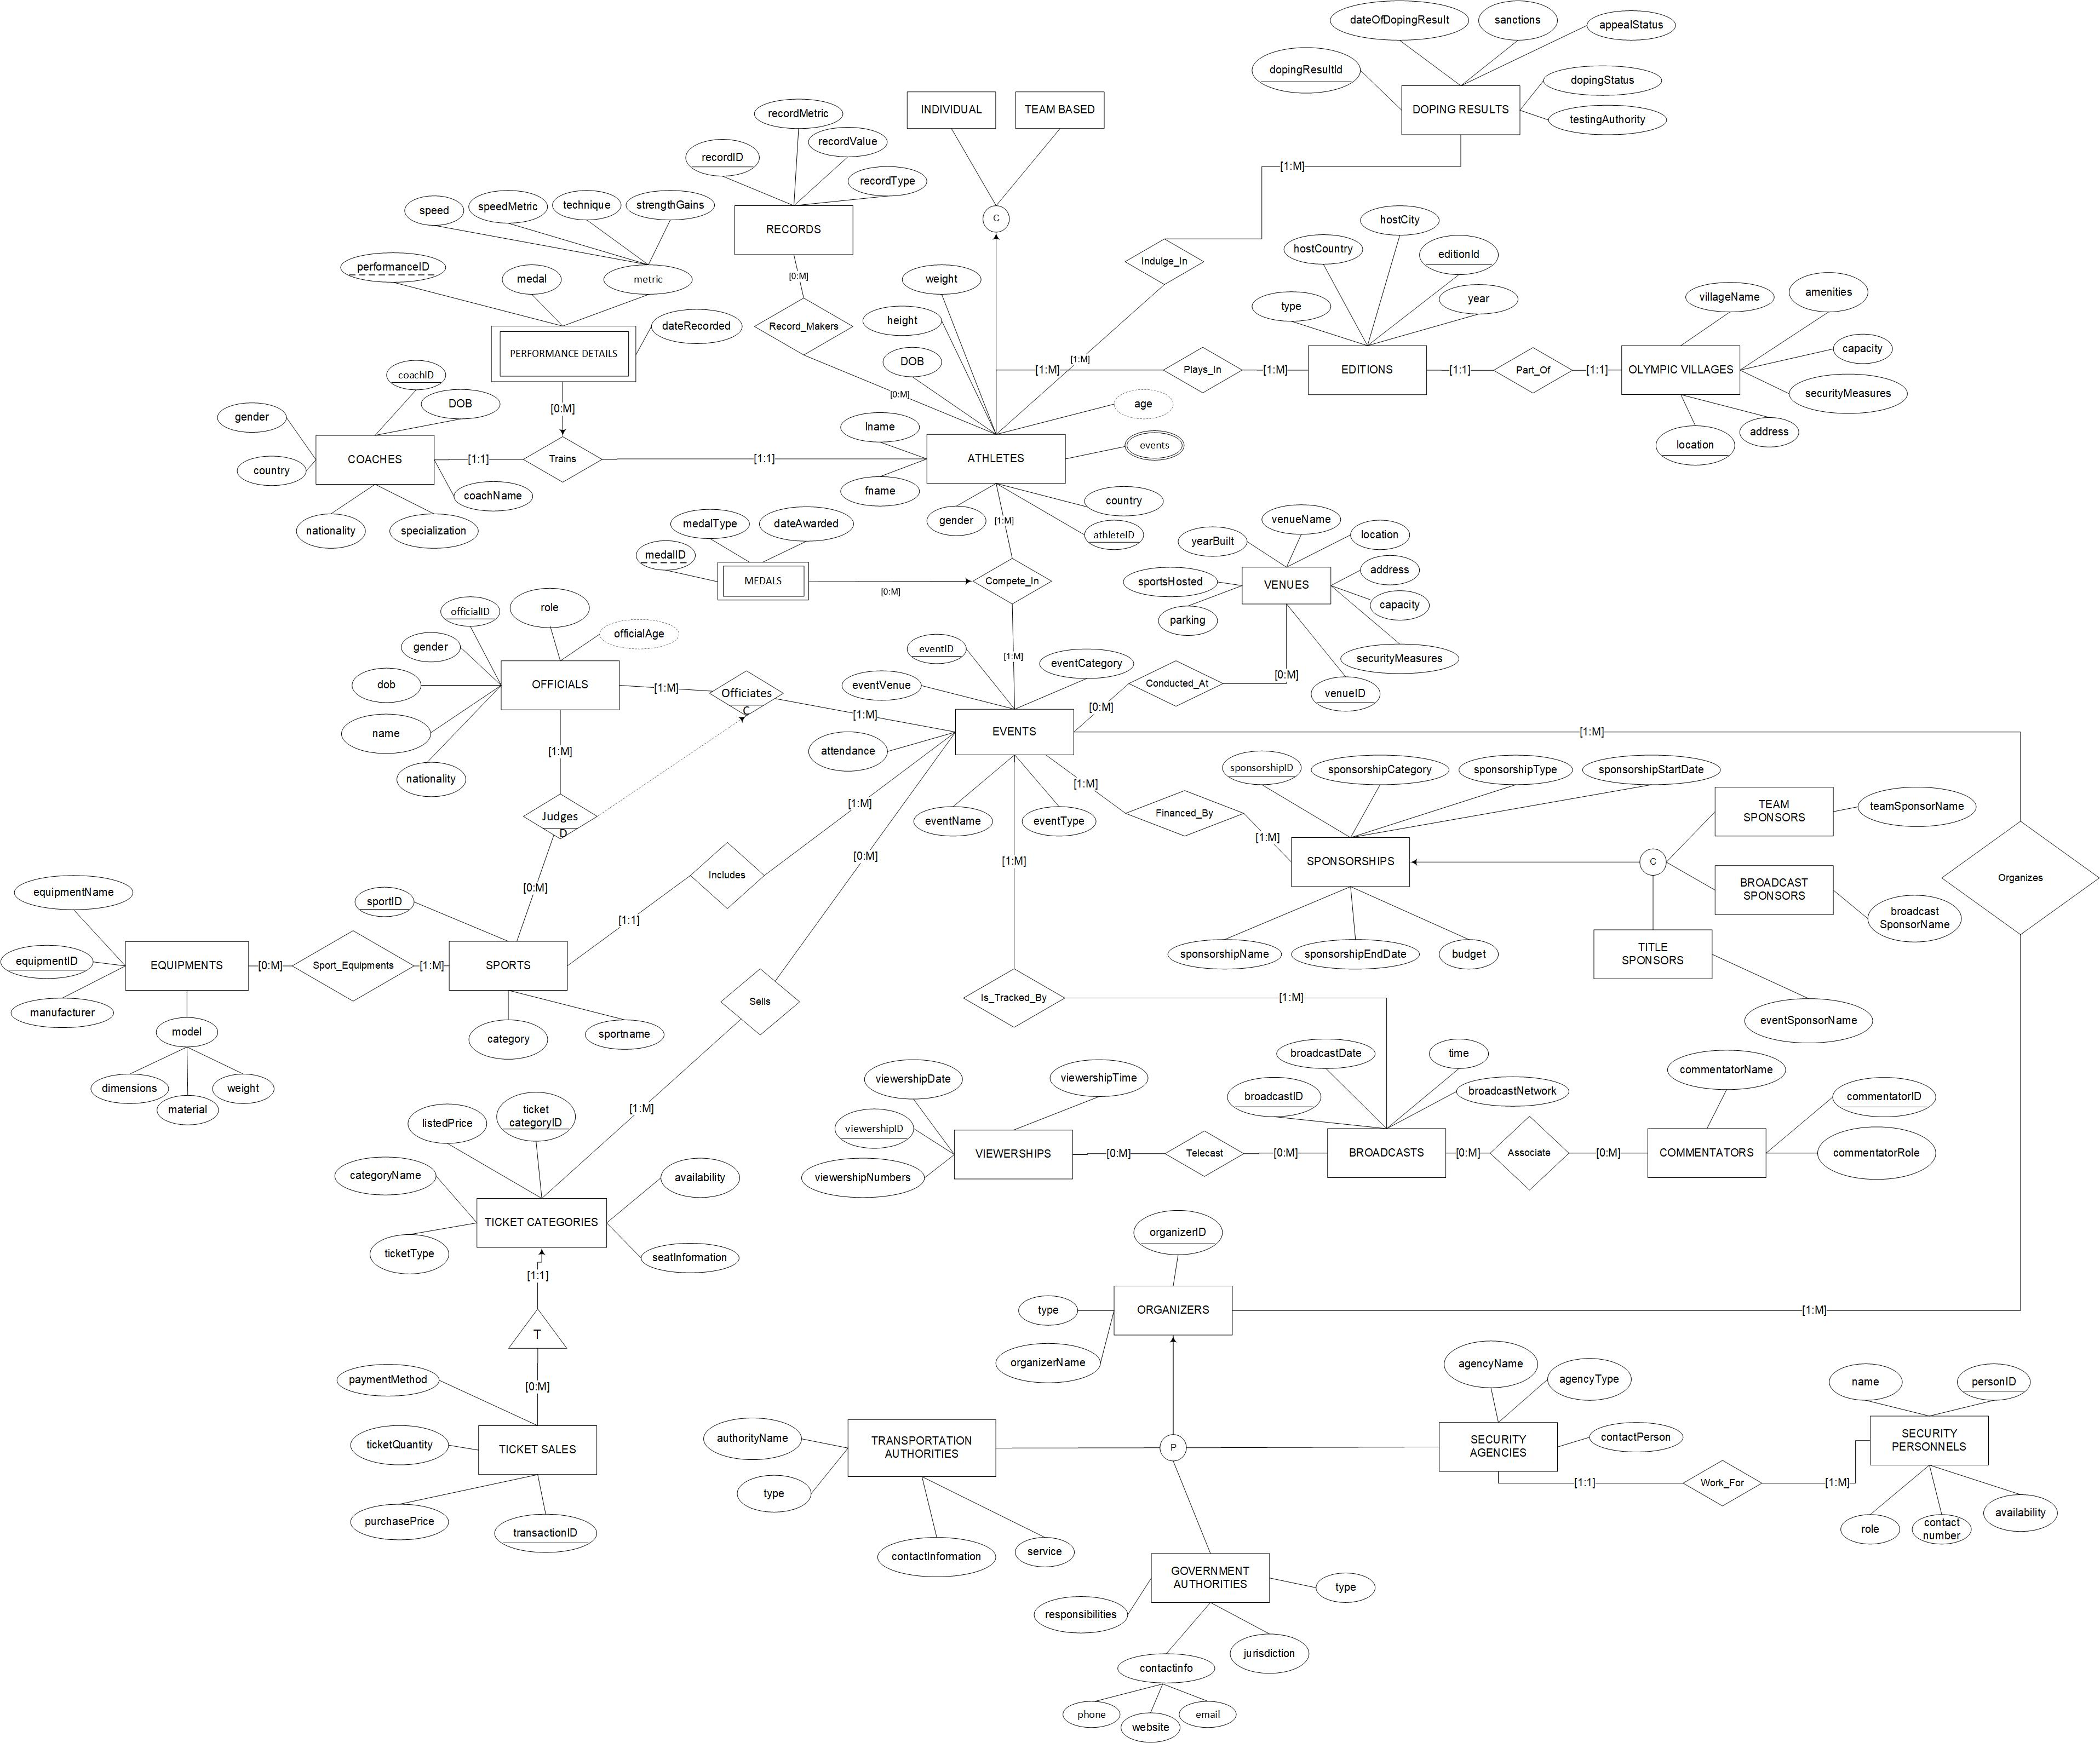

## **2.2 ER Diagram**

# Chapter 3

## **3.1 Relational Schema**

Tables for Strong Entity Classes (including superclasses and sub-classes).

Relations for Multi-valued attributes.

* **ATHLETES** (athleteID, country, gender, fname, lname, DOB, height, weight)

**ATHLETES_EVENTS** (athleteID, events)

Foreign key (athleteID) references **ATHLETES**

* **BROADCASTS** (broadcastID, broadcastDate, time, broadcastNetwork)
* **COACHES (**coachID, coachName, gender, country, nationality, specialization, DOB**)**
* **COMMENTATORS** (commentatorID, commentatorName, commentatorRole)
* **DOPING_RESULTS (**dopingResultID, dateOfDopingResult, sanctions, appealStatus, dopingStatus, testingAuthority**)**
* **EDITIONS** (editionID, type, hostCity, hostCountry, year)
* **EQUIPMENTS** (equipmentID, equipmentName, manufacturer, dimensions, material, weight)
* **EVENTS (**eventID, eventVenue, attendance, eventName, eventType, eventCategory**)**
* **OFFICIALS** (officialID, name, nationality, gender, dob, role, age)
* **OLYMPICS_VILLAGE** (Location, securityMeasures, capacity, amenities, villageName, address)
* **ORGANIZERS** (organizersID, type, organizersName)

**CONTACT_INFO** (organizersID, phone, email)

Foreign key (organizersID) references **ORGANIZERS**

Subclass Translation of ORGANIZERS

* + **TRANSPORTATION_AUTHORITIES** (transportationID, authorityName, type, contactInformation, service)

Foreign key (transportationID) references **ORGANIZERS** (organizersID)

* + **SECURITY_AGENCIES** (agencyID, agencyName, agencyType, contactPerson)

Foreign key (agencyID) references **ORGANIZERS**(organizersID)

* + **GOVERNMENT_AUTHORITIES** (governmentID, type, jurisdiction, phone, website, email, responsibilities)

Foreign key (governmentID) references **ORGANIZERS**(organizersID)

* **RECORDS (**recordID, recordValue, recordType, recordMetric**)**
* **SECURITY­_PERSONNELS (**personID, agencyID, name, role, contactNumber, availability)

Foreign Key (agencyID) references **SECURITY_AGENCIES**

* **SPONSORSHIPS (**sponsorshipID, sponsorshipCategory, sponsorshipType, sponsorshipStartDate, budget, sponsorshipEndDate, sponsorshipName**)**

Subclass Translation of SPONSORSHIPS

* **BROADCAST_SPONSORS (**sponsorshipID, broadcastSponsorName**)**

Foreign key (sponsorshipID) references **SPONSORSHIP**

* **TEAM_SPONSORS (**sponsorshipID, teamSponsorName**)**

Foreign key (sponsorshipID) references **SPONSORSHIP**

* **TITLE_SPONSORS (**sponsorshipID, eventSponsorName**)**

Foreign key (sponsorshipID) references **SPONSORSHIP**

* **SPORTS** (sportID, sportname, category)
* **TICKET_CATEGORIES** (ticketcategoryID, listedPrice, categoryName, ticketType, availability, seatInformation)
* **TICKET_SALES** (transactionID, ticketcategoryID, purchasePrice, ticketQuantity, paymentMethod)  
  Foreign Key (ticketcategoryID) references TICKET_CATEGORIES
* **VENUE (**venueID, securityMeasures, capacity, address, location, venueName, yearBuilt, sportsHosted, parking**)**

* **VIEWERSHIP** (Viewership ID, viewershipNumbers, viewershipDate, viewershipTime)

Relationship and Weak Entity Class tables

* **ASSOCIATE** (commentatorID, broadcastID)   
  Foreign key (commentatorID) references **COMMENTATORS**

Foreign key (broadcastID) references **BROADCASTS**

* **ATHLETE_RECORDS (**athleteID, recordID**)**

Foreign key (athleteID) references **ATHLETES**

Foreign key (recordID) references **RECORDS**

* **CONDUCTED_AT (**venueID, eventID)

Foreign key (venueID) references **VENUES**

Foreign key (eventID) references **EVENTS**

* **FINANCED_BY (**eventID, sponsorshipID)

Foreign key (eventID) references **EVENTS**

Foreign key (sponsorshipID) references **SPONSORSHIPS**

* **INDULGE_IN** (dopingResultID, athleteID)

Foreign key (dopingResultID) references **DOPING_RESULTS**

Foreign key (athleteID) references **ATHLETES**

* **IS_TRACKED_BY** (broadcastID, eventID)

Foreign key (broadcastID) references **BROADCASTS**

Foreign key (eventID) references **EVENTS**

* **JUDGES** (officialID, sportID)

Foreign Key (officialID) references **OFFICIALS**

Foreign Key (sportID) references **SPORTS**

* **MEDALS (**medalID**,** athleteID, eventID, medalType, dateAwarded)

Foreign Key (athleteID) references **ATHLETES**

Foreign Key (eventID) references **EVENTS**

* **OFFICIATES** (officialID, eventID)

Foreign Key (officialID) references **OFFICIALS**

Foreign Key (eventID) references **EVENTS**

* **ORGANIZES** (organizersID, eventID)

Foreign Key (organizersID) references **ORGANIZERS**

Foreign Key (eventID) references **EVENTS**

* **PERFORMANCE_DETAILS (**performanceID, athleteID, coachID, medal, dateRecorded, speed, speedMetric, technique, strengthGains**)**

Foreign key (athleteID) references **ATHLETES**

Foreign key (coachID) references **RECORDS**

* **PLAYS_IN** (editionID, athleteID)

Foreign key (editionID) references **EDITIONS**

Foreign key (athleteID) references **ATHLETES**

* **SELLS** (eventID, ticketCategoryID)

Foreign key (eventID) references **EVENTS**

Foreign key (ticketCategoryID) references **TICKET_CATEGORIES**

* **SPORTS_EQUIPMENTS** (equipmentID, sportID)

Foreign Key (equipmentID) references **EQUIPMENTS**

Foreign Key (sportID) references **SPORTS**

* **TELECAST** (viewershipID, broadcastID)  
  Foreign key (broadcastID) references **BROADCASTS**

Foreign key (viewershipID) references **VIEWERSHIPS**

## **3.2 Data Dictionary**

|  |  |  |
| --- | --- | --- |
| **Schema Construct** | **Data type** | **Constraint** |
| **ATHLETES** | Relation representing the entity class ATHLETES | |
| athleteID | char (6) | Primary Key |
| country | varchar2 (30) | NOT NULL |
| gender | varchar2 (10) | CHECK (Gender IN ('Male', 'Female')) |
| fname | varchar2 (20) | NOT NULL |
| lname | varchar2 (20) | NOT NULL |
| DOB | DATE | NOT NULL |
| height | number (5,2) | NOT NULL |
| weight | number (5,2) | NOT NULL |
| FD: athleteID → athleteID, country, gender, Fname, Lname, DOB, height, weight | | |
| **ATHLETES_EVENTS** Relation for the multi-valued attribute ATHLETES(events) | | |
| athleteID | char(6) | Primary key(composite); Foreign key, references ATHLETES |
| Event | varchar2(50) | NOT NULL |
| **BROADCASTS** | Relation representing the entity class BROADCASTS | |
| braodcastID | char(6) | Primary Key |
| broadcastNetwork | varchar(6) | NOT NULL |
| broadcastDate | DATE | NOT NULL |
| time | TIME | NOT NULL |
| FD: BroadcastID -> BroadcastNetwork, Date, Time | | |
| **COACHES** | Relation representing the entity class COACH | |
| coachID | char (6) | Primary Key |
| coachName | varchar2 (25) | NOT NULL |
| gender | varchar2 (10) | CHECK (Gender IN ('Male', 'Female')) |
| country | varchar2 (30) | NOT NULL |
| nationality | varchar2 (30) | NOT NULL |
| specialization | varchar2 (100) | CHECK (LEN(specialization) <= 100) |
| DOB | DATE | NOT NULL |
| FD: coachID → coachID, coachName, gender, country, nationality, specialization, DOB | | |

|  |  |  |  |
| --- | --- | --- | --- |
| **Schema Construct** | **Data type** | **Constraint** | **Constraint** |
| **COMMENTATORS** | Relation representing the entity class COMMENTATORS | |
| commentatorsID | char(6) | Primary Key |
| commentatorName | varchar(20) | UNIQUE |
| commentatorRole | varchar(20) | NOT NULL |
| Table level constraint | | |
| FD: CommentatorsID -> CommentatorsID, CommentatorsName, CommentatorRole | | |

|  |  |  |
| --- | --- | --- |
| **DOPING_RESULTS** | Relation representing the entity class Doping Results | |
| dopingResultID | char(6) | Primary Key |
| dateOfDopingResult | DATE | NOT NULL |
| sanctions | varchar2(25) | NOT NULL |
| appealStatus | varchar2(25) | NOT NULL |
| dopingStatus | varchar2(25) | NOT NULL |
| testingAuthority | varchar2(25) | NOT NULL |
| FD1: dopingResultID -> dateOfDopingResult, sanctions, appealStatus, dopingStatus, testingAuthority | | |

|  |  |  |
| --- | --- | --- |
| **EDITIONS** | Relation representing the entity class **EDITION** | |
| editionID | char(6) | PRIMARY KEY |
| type | varchar2(30) | NOT NULL |
| hostCity | varchar2(30) | NOT NULL |
| hostCountry | varchar2(30) | NOT NULL |
| year | DATE | NOT NULL |
| FD: EditionID→ type, hostCity, hostCountry, year | | |

|  |  |  |
| --- | --- | --- |
| **EQUIPMENTS** | Relation representing the entity class **EQUIPMENTS** | |
| equipmentID | char (6) | Primary Key |
| equipmentName | varchar2 (25) | NOT NULL |
| manufacturer | varchar2 (25) | NOT NULL |
| dimensions | number (4,2) | NOT NULL |
| material | varchar2 (25) | NOT NULL |
| weight | number (4,2) | NOT NULL |
| FD1: equipmentID -> equipmentName, manufacturer, dimensions, material, weight | | |

|  |  |  |  |
| --- | --- | --- | --- |
| **Schema Construct** | **Data type** | **Constraint** |  |
| **EVENTS** | Relation representing the entity class **EVENTS** | |
| eventID | char (6) | Primary Key |
| eventVenue | varchar2 (25) | NOT NULL |
| attendance | number(6) | CHECK (attendance > 0) |
| eventName | varchar2 (25) | Unique |
| eventType | varchar2 (25) | NOT NULL |
| eventCategory | varchar2 (25) | NOT NULL |
| *Table-level constraints* | | |
| CHECK (eventType <> eventCategory) | | |
| FD1: eventID → eventID, eventVenue, eventName, eventType, eventCategory | | |

|  |  |  |
| --- | --- | --- |
| **OFFICIALS** | Relation representing the entity class **OFFICIALS** | |
| officialID | char (6) | Primary Key |
| name | varchar2 (25) | UNIQUE |
| nationality | varchar2 (25) | NOT NULL |
| gender | varchar2 (10) | CHECK (Gender IN ('Male', 'Female')) |
| DOB | DATE | NOT NULL |
| role | varchar2 (25) | NOT NULL |
| age | number (4,2) | NOT NULL |
| FD1: officialID -> name, nationality, gender, dob, role, age | | |
| **OLYMPICS_VILLAGE** | Relation representing the entity class **OLYMPICS_VILLAGE** | |
| location | VARCHAR(30) | Primary Key |
| securityMeasures | VARCHAR(255) |  |
| capacity | INT | CHECK (capacity > 0) |
| amenities | varchar2(30) |  |
| villageName | varchar2(30) |  |
| address | TEXT |  |
| FD1: location -> security_measures, capacity, amenities, village_name, address, location | | |  |  |

|  |  |  |  |
| --- | --- | --- | --- |
| **Schema Construct** | **Data Type Constraint** | |  |
| **ORGANIZERS** | Relation representing the entity class **ORGANIZERS** | | |
| organizersID | char(6) | Primary Key | |
| type | varchar2(25) | CHECK (type IN (‘GOVERNMENT_AUTHORITY’, GOVERNMENT_AUTHORITY’,‘TRANSPORTATION_AUTHORITY’, ‘SECURITY_AGENCY)) | |
| organizersName | varchar2(25) | NOT NULL | |
| FD1: organizersID -> organizers_name, type | | | |

|  |  |  |
| --- | --- | --- |
| **CONTACT_INFO** | Relation for the multi-valued attribute ORGANIZERS(contact_info) | |
| organizersID | char(6) | Primary key(composite); Foreign key, references ORGANIZERS |
| phone | varchar2(50) | NOT NULL |
| email | varchar2(50) | NOT NULL |

|  |  |  |  |  |
| --- | --- | --- | --- | --- |
| **TRANSPORTATION_AUTHORITY** | | Subclass translation of **ORGANIZERS** representing the entity class **TRANSPORTATION_AUTHORITY** | | |
| transportationID | | char(6) | | Primary Key; Foreign key, references ORGANIZERS |
| authorityName | | varchar2(25) | | NOT NULL |
| type | | varchar2(25) | | NOT NULL |
| contactInformation | | varchar2(255) | | UNIQUE |
| service | | varchar2(25) | | NOT NULL |
| FD1: transportationID -> authorityName, type, contactInformation, Service | | | | |
| **SECURITY_AGENCY** | Subclass translation of **ORGANIZERS** representing the entity class **SECURITY_AGENCY** | | | |
| agencyID | char(6) | | Primary Key; Foreign key, references ORGANIZERS | |
| agencyName | varchar2(25) | | NOT NULL | |
| agencyType | varchar2(25) | | NOT NULL | |
| contactPerson | varchar2(25) | | NOT NULL | |
| FD1: agencyID -> agencyName, agencyType, contactPerson | | | | |

|  |  |  |
| --- | --- | --- |
| **Schema Construct** | **Data type** | **Constraint** |

|  |  |  |
| --- | --- | --- |
| **GOVERNMENT_AUTHORITY** | Subclass translation of **ORGANIZERS** representing the entity class **GOVERNMENT_AUTHORITY** | |
| governmentID | char(6) | Primary Key; Foreign key, references ORGANIZERS |
| type | varchar2(25) | NOT NULL |
| jurisdiction | varchar2(25) | NOT NULL |
| phone | varchar2(25) | UNIQUE |
| website | varchar2(25) | UNIQUE |
| email | varchar2(25) | UNIQUE |
| responsibilities | varchar2(50) | NOT NULL |
| FD1: governmentID -> Type, Jurisdiction, responsibilities, phone, email, website | | |
| **RECORDS** | Relation representing the entity class **RECORDS** | |
| recordID | char (6) | Primary Key |
| recordValue | number (10,2) | NOT NULL |
| recordMetric | varchar2 (30) | NOT NULL |
| recordType | varchar2 (30) | NOT NULL |
| FD: recordID → recordValue, recordType, recordMetric | | |
| **SECURITY-PERSONNEL** | relation representing the entity class **SECURITY-PERSONNEL** | |
| personID | char(6) | Primary Key |
| agencyID | char(6) | Primary Key |
| name | Varchar(20) | NOT NULL |
| role | Varchar(15) | Unique |
| contactPerson | Number(10) | Unique |
| availabilty | char(2) | NOT NULL |
| FD: PersonID -> PersonID, Name, Role, ContactNo , Availabilty, agencyID | | |

|  |  |  |
| --- | --- | --- |
| **Schema Construct** | **Data type** | **Constraint** |

|  |  |  |
| --- | --- | --- |
| **SPONSORSHIP** | Relation representing the entity class **SPONSORSHIP** | |
| sponsorshipID | char (6) | Primary Key |
| sponsorshipName | varchar2 (25) | Unique |
| sponsorshipCategory | varchar2 (25) | NOT NULL |
| sponsorshipType | varchar2 (25) | CHECK (sponsorshipType IN (‘title’, ‘presenting’, ‘official’, ‘team’, ‘digital’, ‘broadcast’)) |
| sponsorshipStartDate | date | NOT NULL |
| sponsorshipEndDate | date | NOT NULL |
| budget | number(8) | CHECK (budget > 0) |
| *Table-level constraints* | | |
| CHECK (sponsorshipStartDate <= sponsorshipEndDate) | | |
| This constraint has been added based on peer feedback to avoid errors | | |
| FD1: sponsorshipID → sponsorshipID, sponsorshipName, sponsorshipCategory, sponsorshipType, sponsorshipStartDate, sponsorshipEndDate | | |
| **BROADCAST_SPONSORS** | Subclass translation of **SPONSORSHIPS** representing the entity class **BROADCAST_SPONSOR** | |
| sponsorshipID | char (6) | Primary key; Foreign key references SPONSORSHIP |
| broadcastSponsorName | varchar2 (25) | NOT NULL |
| FD: sponsorshipID → broadcastSponsorName | | |
| **TEAM_SPONSOR** | Subclass translation of **SPONSORSHIPS** representing the entity class **TEAM_SPONSOR** | |
| sponsorshipID | char (6) | Primary key; Foreign key references SPONSORSHIP |
| teamSponsorName | varchar2 (25) | NOT NULL |
| FD: sponsorshipID → teamSponsorName | | |
| **TITLE_SPONSOR** | Subclass translation of SPONSORSHIPS representing the entity class TITLE_SPONSOR | |
| sponsorshipID | char(6) | Primary Key, Foreign Key, references SPONSORS |
| eventSponsorName | varchar2(25) | Unique |
| FD1: sponsorshipID -> sponsorshipID, eventSponsorName | | |

|  |  |  |
| --- | --- | --- |
| **Schema Construct** | **Data type** | **Constraint** |

|  |  |  |  |  |
| --- | --- | --- | --- | --- |
| SPORTS | | Relation representing the entity class SPORTS | | |
| sportID | | char (6) | Primary Key | |
| sportName | | varchar2 (25) | UNIQUE | |
| category | | varchar2 (25) | NOT NULL | |
| FD1: sportID → sportID, sportname, category | | | | |
| **TICKET_CATEGORY** | Relation representing the entity class **TICKET_CATEGORY** | | | |
| ticketCategoryID | char(6) | | Primary key | |
| listedPrice | DECIMAL(10, 2) | | NOT NULL | |
| categoryName | VARCHAR(255) | | NOT NULL | |
| ticketType | varchar2(30) | | NOT NULL | |
| availability | varchar2(30) | | NOT NULL | |
| seatInformation | TEXT | | NOT NULL | |
| FD1: ticketcategoryID → listedPrice, categoryName, ticketType, availability, seatInformation | | | | |
| TICKET_SALE | Relation representing the entity class Ticket_sale | | | |
| transactionID | char (6) | | Primary Key | |
| ticketcategoryID | char (6) | | Foreign key, references TICKET_CATEGORY | |
| purchasePrice | number (4,2) | |  | |
| ticketQuantity | number (4,2) | | NOT NULL | |
| paymentMethod | varchar2 (25) | | NOT NULL | |
| Table-level constraints |  | |  | |
| FD1: transactionID -> ticketcategoryID, purchasePrice, ticketQuantity, paymentMethod | | | | |
| **VENUE** | Relation representing the entity class VENUE | | | |
| venueID | char (6) | | | Primary Key |
| securityMeasures | varchar2 (20) | | | NOT NULL |
| capacity | number (10,2) | | | NOT NULL |
| address | varchar2 (60) | | | NOT NULL |
| location | varchar2 (30) | | | NOT NULL |
| venueName | varchar2 (30) | | | NOT NULL |
| yearBuilt | DATE | | | NOT NULL |
| sportsHosted | varchar2 (100) | | | NOT NULL |
| parking | number (5,2) | | | NOT NULL |
| FD: venueID → securityMeasures, capacity, address, location, venueName, yearBuilt, sportsHosted, parking | | | | |

|  |  |  |
| --- | --- | --- |
| **Schema Construct** | **Data type** | **Constraint** |

|  |  |  |
| --- | --- | --- |
| **VIEWERSHIP** | Relation representing the entity class Viewership | |
| viewershipID | char(6) | Primary Key |
| viewershipNumbers | number(10) | CHECK ( ViewershipNumbers >0 ) |
| viewershipDate | Date | NOT NULL |
| viewershipTime | TIME | NOT NULL |
| FD: ViewershipID -> ViewershipID, ViewershipNumber, ViewershipDate, ViewershipTime | | |

Relationship and Weak Entity Class Tables

|  |  |  |
| --- | --- | --- |
| **Schema Construct** | **Data type** | **Constraint** |

|  |  |  |
| --- | --- | --- |
| **ASSOCIATES** | relation representing the entity class Associates | |
| commentatorsID | char(6) | Primary Key (composite), Foreign Key, references COMMENTATORS |
| braodcastID | varchar(20) | Primary Key (composite), Foreign Key, references BROADCAST |
| FD: CommentatorsID, BroadcastNetworks -> CommentatorsID, BroadcastNetworks | | |

|  |  |  |
| --- | --- | --- |
| **ATHLETE_RECORDS** | relation representing the entity class ATHLETES_RECORDS | |
| athleteID | char (6) | Primary key; Foreign key references ATHLETES |
| recordID | char (6) | Primary key; Foreign key references RECORDS |
| FD: athleteID, recordID → recordID, athleteID | | |

|  |  |  |
| --- | --- | --- |
| **CONDUCTED_AT** | Relation representing the relationship **CONDUCTED_AT** across the entity classes **VENUE** and **EVENTS** | |
| eventID | char (6) | Primary key; Foreign key references EVENTS |
| venueID | char (6) | Primary key; Foreign key references VENUE |
| FD: eventID, venueID → eventID, venueID | | |

|  |  |  |
| --- | --- | --- |
| **FINANCED_AT** | Relation representing the relationship **CONDUCTED_AT** across the entity classes **VENUE** and **EVENTS** | |
| eventID | char (6) | Primary key; Foreign key references EVENTS |
| sponsorshipID | char (6) | Primary key; Foreign key references SPONSORSHIP |
| FD: eventID, sponsorshipID → eventID, sponsorshipID | | |

|  |  |  |
| --- | --- | --- |
| **Schema Construct** | **Data type** | **Constraint** |

|  |  |  |
| --- | --- | --- |
| **INDULGES_IN** | Relation representing the relationship **INDULGES_IN** across the entity classes **DOPING_RESULTS** and **ATHLETE** | |
| dopingResultID | char(6) | Primary key; Foreign key references EVENTS |
| athleteID | char(6) | Primary key; Foreign key references EVENTS |
| FD: dopingResultID, athleteID → dopingresultID, athleteID | | |

|  |  |  |
| --- | --- | --- |
| **IS_TRACKED_BY** | Relation representing the relationship **IS_TRACKED_BY** across the entity classes **broadcastID and eventID** | |
| broadcastID | char(6) | Primary key; Foreign key references BROADCASTS |
| EventID | char(6) | Primary key; Foreign key references EVENTS |

|  |  |  |
| --- | --- | --- |
| **JUDGES** | Relation representing the entity class Judges | |
| officialID | char (6) | Primary key (composite); Foreign key references OFFICIALS |
| sportID | char (6) | Primary key (composite); Foreign key references SPORTS |
| FD1 : officialID, sportID → officialID, sportID | | |

|  |  |  |
| --- | --- | --- |
| **MEDALS** | **Relation representing the entity class MEDALS** | |
| medalID | char(6) | Primary key |
| athleteID | char(6) | Primary key; Foreign key references ATHLETES |
| eventID | char(6) | Primary key; Foreign key references EVENTS |
| medalType | varchar2(30) | NOT NULL |
| dateAwarded | DATE | NOT NULL |
| FD1: medalID, eventID, athleteID → medalID, eventID, athleteID, medalType, dateAwarded | | |

|  |  |  |
| --- | --- | --- |
| **OFFICIATES** | Relation representing the entity class **OFFICIATES** | |
| officialID | char (6) | Primary key (composite); Foreign key references OFFICIALS |
| eventID | char (6) | Primary key (composite); Foreign key references EVENTS |
| FD1 : officialID, eventID → officialID, eventID | | |

|  |  |  |
| --- | --- | --- |
| **ORGANIZES** | Relation representing the entity class **ORGANIZES** | |
| organizersID | char (6) | Primary key (composite); Foreign key references ORGANIZERS |
| eventID | char (6) | Primary key (composite); Foreign key references EVENTS |
| FD1 : organizersID, eventID → organizersID, eventID | | |

|  |  |  |
| --- | --- | --- |
| **Schema Construct** | **Data type** | **Constraint** |

|  |  |  |
| --- | --- | --- |
| **PERFORMANCE_DETAILS** | Relation representing the entity class PERFORMANCE_DETAILS | |
| performanceID | char (6) | Primary Key |
| athleteID | char (6) | Foreign key, references ATHLETES |
| coachID | char (6) | Foreign key, references COACHES |
| medal | varchar2 (3) | CHECK (medal IN ('Yes', 'No')) |
| dateRecorded | DATE | NOT NULL |
| speed | number (4,2) | CHECK (speed <= 35) |
| speedMetric | varchar2 (30) | CHECK (speedMetric IN ('MPH')) |
| technique | varchar2 (30) | NOT NULL |
| strengthGains | varchar2 (30) | NOT NULL |
| FD4: performanceID, athleteID, coachID → performanceID, athleteID, coachID, medal, dateRecorded, speed, speedMetric, technique, strengthGains | | |

|  |  |  |
| --- | --- | --- |
| **PLAYS_IN** | **Relation representing the relationship PLAYS_IN across the entity classes EDITION and ATHLETE** | |
| editionID | char(6) | Primary key; Foreign key references EDITION |
| athleteID | char(6) | Primary key; Foreign key references EVENTS |
| FD: editionID, athleteID → editionID, athleteID | | |

|  |  |  |
| --- | --- | --- |
| **SELLS** | **Relation representing the relationship SELLS across the entity classes EQUIPMENTS and SPORTS** | |
| eventID | char(6) | Primary key; Foreign key references EVENTS |
| ticketCategoryID | char(6) | Primary key; Foreign key references EQUIPMENTS |
| FD: eventID , ticketCategoryID → eventID , ticketCategoryID | | |
|  | | |

|  |  |  |
| --- | --- | --- |
| **SPORTS_EQUIPMENTS** | Relation representing the entity class Sports_Equipments | |
| equipmentID | char (6) | Primary key; Foreign key references EQUIPMENTS |
| sportID | char (6) | Primary key; Foreign key references SPORTS |
| FD1: equipmentID, sportID → equipmentID, sportID | | |

|  |  |  |
| --- | --- | --- |
| **TELECAST** | relation representing the entity class Telecast | |
| braodcastID | char(6) | Primary Key, Foreign Key, references BROADCAST |
| viewershipID | char(6) | Primary Key , Foreign Key, references VIEWERSHIP |
| FD: braodcastID , ViewershipID -> ViewershipID, braodcastID | | |

## **3.3 DDL Appendix**

SQL statements to create all your tables (and define constraints).

1. ASSOCIATES

CREATE TABLE ASSOCIATES (CommentatorsID CHAR(6), broadcastID VARCHAR2(20), PRIMARY KEY (CommentatorsID, broadcastID), FOREIGN KEY (CommentatorsID) REFERENCES COMMENTATORS (commentatorID), FOREIGN KEY (broadcastID) REFERENCES BROADCAST (broadcastID));

1. ATHLETES_UPDATED

CREATE TABLE ATHLETES_UPDATED (athleteID CHAR(6) PRIMARY KEY, country VARCHAR2(30) NOT NULL, gender VARCHAR2(10) CHECK (gender IN ('Male', 'Female')), Fname VARCHAR2(20) NOT NULL, Lname VARCHAR2(20) NOT NULL, DOB DATE NOT NULL, height NUMBER(5,2) NOT NULL, weight NUMBER(5,2) NOT NULL);

1. ATHLETES_RECORDS

CREATE TABLE ATHLETE_RECORDS (athleteID CHAR(6),recordID CHAR(6), PRIMARY KEY (athleteID, recordID), FOREIGN KEY (athleteID) REFERENCES ATHLETES(athleteID), FOREIGN KEY (recordID) REFERENCES RECORDS(recordID));

1. AUDIT_LOG

CREATE TABLE AUDIT_LOG (operationType VARCHAR2(10) NOT NULL, tableName VARCHAR2(30) NOT NULL, columnName VARCHAR2(30) NOT NULL, oldValue VARCHAR2(255), newValue VARCHAR2(255), dateChanged TIMESTAMP NOT NULL);

1. BROADCAST

CREATE TABLE BROADCAST (broadcastID VARCHAR2(6) PRIMARY KEY, BroadcastNetwork VARCHAR2(6) NOT NULL, BroadcastDate DATE NOT NULL, Time TIMESTAMP(0) NOT NULL);

1. BROADCAST_EVENTS

CREATE TABLE BROADCAST_EVENTS (eventID CHAR(6), broadcastID CHAR(6), PRIMARY KEY (eventID, broadcastID), FOREIGN KEY (eventID) REFERENCES EVENTS (eventID), FOREIGN KEY (broadcastID) REFERENCES BROADCAST (broadcastID));

1. BROADCASTSPONSOR

CREATE TABLE BROADCASTSPONSOR (sponsorshipID CHAR(6), broadcastSponsorName VARCHAR2(25) NOT NULL, PRIMARY KEY (sponsorshipID), FOREIGN KEY (sponsorshipID) REFERENCES SPONSORSHIP(sponsorshipID));

1. COACH

CREATE TABLE COACH (coachID CHAR(6) PRIMARY KEY, coach_name VARCHAR2(25) NOT NULL, gender VARCHAR2(10) CHECK (gender IN ('Male', 'Female')), country VARCHAR2(30) NOT NULL, nationality VARCHAR2(30) NOT NULL, specialization VARCHAR2(100) CHECK (LENGTH(specialization) <= 100), DOB DATE NOT NULL);

1. COMMENTATORS

CREATE TABLE COMMENTATORS (commentatorID CHAR(6) PRIMARY KEY, commentatorName VARCHAR2(20) UNIQUE, commentatorRole VARCHAR2(20) NOT NULL);

1. CONDUCTED_AT

CREATE TABLE CONDUCTED_AT (eventID CHAR(6), venueID CHAR(6), PRIMARY KEY (eventID, venueID), FOREIGN KEY (eventID) REFERENCES EVENTS_UPDATED(eventID), FOREIGN KEY (venueID) REFERENCES VENUE(venueID));

1. CONTACT_INFO

CREATE TABLE CONTACT_INFO (organizersID CHAR(6) PRIMARY KEY, phone NUMBER(10), email VARCHAR(50), FOREIGN KEY (organizersID) REFERENCES ORGANIZERS(organizersID));

1. DOPING_RESULTS

CREATE TABLE DOPING_RESULTS (dopingResultID CHAR(6) PRIMARY KEY, dateOfDopingResult DATE NOT NULL, sanctions VARCHAR2(25) NOT NULL, appealStatus VARCHAR2(25) NOT NULL, dopingStatus VARCHAR2(25) NOT NULL, testingAuthority VARCHAR2(25) NOT NULL);

1. EDITIONS

CREATE TABLE EDITIONS (editionID CHAR(6) PRIMARY KEY, type VARCHAR2(30) NOT NULL, hostCity VARCHAR2(30) NOT NULL, hostCountry VARCHAR2(30) NOT NULL, year DATE NOT NULL);

1. EQUIMENTS

CREATE TABLE EQUIPMENTS (equipmentID CHAR(6) PRIMARY KEY, equipmentName VARCHAR2(25) NOT NULL, manufacturer VARCHAR2(25) NOT NULL, dimensions NUMBER(4,2) NOT NULL, material VARCHAR2(25) NOT NULL, weight NUMBER(4,2) NOT NULL);

1. EVENTS_UPDATED

CREATE TABLE EVENTS_UPDATED (eventID CHAR(6) PRIMARY KEY, eventVenue VARCHAR2(100) NOT NULL, attendance NUMBER(6) CHECK (attendance > 0), eventName VARCHAR2(100), eventType VARCHAR2(100) NOT NULL, eventCategory VARCHAR2(25) NOT NULL, EventDate DATE, sportID CHAR(6), FOREIGN KEY (sportID) REFERENCES sports(sportid) CONSTRAINT chk_event_type_category CHECK (eventType <> eventCategory));

1. FINANCED_AT

CREATE TABLE FINANCED_AT (eventID CHAR(6), sponsorshipID CHAR(6), PRIMARY KEY (eventID, sponsorshipID), FOREIGN KEY (eventID) REFERENCES EVENTS_UPDATED(eventID), FOREIGN KEY (sponsorshipID) REFERENCES SPONSORSHIP(sponsorshipID));

1. GOVERNMENT_AUTHORITIES

CREATE TABLE GOVERNMENT_AUTHORITIES (governmentID CHAR(6) PRIMARY KEY, type VARCHAR(20), jurisdiction VARCHAR(50), phone NUMBER(10), website VARCHAR(100), email VARCHAR(50), responsibilities VARCHAR(200), FOREIGN KEY (governmentID) REFERENCES ORGANIZERS(organizersID));

1. INDULGES_IN

CREATE TABLE INDULGES_IN (DOPINGRESULTID CHAR(6), athleteID CHAR(6), PRIMARY KEY (DOPINGRESULTID, athleteID), FOREIGN KEY (DOPINGRESULTID) REFERENCES DOPING_RESULTS (DOPINGRESULTID), FOREIGN KEY (athleteID) REFERENCES ATHLETES_UPDATED(athleteID));

1. IS_TRACKED_BY

CREATE TABLE IS_TRACKED_BY (broadcastID CHAR(6), eventID CHAR(6), PRIMARY KEY (broadcastID, eventID), FOREIGN KEY (broadcastID) REFERENCES BROADCASTS(broadcastID), FOREIGN KEY (eventID) REFERENCES EVENTS(eventID));

1. JUDGES

CREATE TABLE JUDGES (officialID CHAR(6), sportID CHAR(6), PRIMARY KEY (officialID, sportID), FOREIGN KEY (officialID) REFERENCES OFFICIALS(officialID), FOREIGN KEY (sportID) REFERENCES SPORTS(sportID));

1. MEDALS_UPDATED

CREATE TABLE MEDALS_UPDATED (medalID CHAR(6), athleteID CHAR(6), eventID CHAR(6), medal_type VARCHAR2(30) NOT NULL, date_awarded DATE, PRIMARY KEY (medalID, eventID, athleteID), FOREIGN KEY (athleteID) REFERENCES ATHLETES_UPDATED(athleteID), FOREIGN KEY (eventID) REFERENCES EVENTS_UPDATED(eventID));

1. OFFICIALS

CREATE TABLE OFFICIALS (officialID CHAR(6) PRIMARY KEY, name VARCHAR2(25) UNIQUE, nationality VARCHAR2(25) NOT NULL, gender VARCHAR2(10) CHECK (gender IN ('Male', 'Female')), DOB DATE NOT NULL, role VARCHAR2(25) NOT NULL, age NUMBER(4,2) NOT NULL);

1. OFFICIATES

CREATE TABLE OFFICIATES (officialID CHAR(6), eventID CHAR(6), PRIMARY KEY (officialID, eventID), FOREIGN KEY (officialID) REFERENCES OFFICIALS(officialID), FOREIGN KEY (eventID) REFERENCES EVENTS(eventID));

1. OLYMPICS_VILLAGE

CREATE TABLE OLYMPICS_VILLAGE (location VARCHAR(30) PRIMARY KEY, securityMeasures VARCHAR(255), capacity INT CHECK (capacity > 0), amenities VARCHAR2(30), villageName VARCHAR2(30), address TEXT);

1. ORGANIZERS

CREATE TABLE ORGANIZERS (organizersID CHAR(6) PRIMARY KEY, type VARCHAR(20), organizers_name VARCHAR(50));

1. ORGANIZES

CREATE TABLE ORGANIZES (organizersID CHAR(6), eventID CHAR(6), PRIMARY KEY (organizersID, eventID), FOREIGN KEY (organizersID) REFERENCES ORGANIZERS(organizersID), FOREIGN KEY (eventID) REFERENCES EVENTS(eventID));

1. PARTS_OF

CREATE TABLE PARTS_OF (edition_id CHAR(6), country_id CHAR(6), PRIMARY KEY (edition_id, country_id), FOREIGN KEY (edition_id) REFERENCES EDITION(editionid), FOREIGN KEY (country_id) REFERENCES COUNTRY(country_id));

1. PERFORMANCE_DETAILS_UPDATED

CREATE TABLE PERFORMANCE_DETAILS_UPDATED ( performanceID CHAR(6) PRIMARY KEY, athleteID CHAR(6), coachID CHAR(6), medal VARCHAR2(3) CHECK (medal IN ('Yes', 'No')), dateRecorded DATE NOT NULL, speed NUMBER(4,2) CHECK (speed <= 35), speedMetric VARCHAR2(30) CHECK (speedMetric IN ('mph')), technique VARCHAR2(30) NOT NULL, strength_gains VARCHAR2(30) NOT NULL, FOREIGN KEY (athleteID) REFERENCES ATHLETES_UPDATED(athleteID), FOREIGN KEY (coachID) REFERENCES COACH(coachID));

1. PLAYS_IN

CREATE TABLE PLAYS_IN (athleteID CHAR(6), editionID CHAR(6), PRIMARY KEY (athleteID, editionID), FOREIGN KEY (athleteID) REFERENCES ATHLETES_UPDATED(athleteID), FOREIGN KEY (editionID) REFERENCES EDITION(editionID));

1. RECORDS

CREATE TABLE RECORDS (recordID CHAR(6) PRIMARY KEY, recordValue NUMBER(10,2) NOT NULL, recordMetric VARCHAR2(20) NOT NULL, recordType VARCHAR2(30) NOT NULL);

1. SECURITY_AGENCIES

CREATE TABLE SECURITY_AGENCIES (agencyID CHAR(6) PRIMARY KEY, agency_name VARCHAR(50), agency_type VARCHAR(20), contact_person NUMBER(10), FOREIGN KEY (agencyID) REFERENCES ORGANIZERS(organizersID) );

1. SECURITY_PERSONNELS

CREATE TABLE SECURITY_PERSONNELS (personID CHAR(6) PRIMARY KEY, agencyID CHAR(6), name VARCHAR(30), role VARCHAR(30), contactNumber NUMBER(10), availability CHAR(2) NOT NULL, FOREIGN KEY (agencyID) REFERENCES SECURITY_AGENCIES(agencyID));

1. SELLS_TICKET_EVENTS

CREATE TABLE SELLS_TICKET_EVENTS (eventID CHAR(6), ticketcategoryID CHAR(6), PRIMARY KEY (eventID, ticketcategoryID), FOREIGN KEY (eventID) REFERENCES EVENTS(eventID), FOREIGN KEY (ticketcategoryID) REFERENCES TICKET_CATEGORY(ticketcategoryID) );

1. SPONSORSHIP

CREATE TABLE SPONSORSHIP (sponsorshipID CHAR(6) PRIMARY KEY, sponsorshipName VARCHAR2(25), sponsorshipCategory VARCHAR2(25) NOT NULL, sponsorshipType VARCHAR2(25) CHECK (sponsorshipType IN ('title', 'presenting', 'official', 'team', 'digital', 'broadcast')), sponsorshipStartDate DATE CHECK (EXTRACT(YEAR FROM sponsorshipStartDate) >= 1896), sponsorshipEndDate DATE CHECK (EXTRACT(YEAR FROM sponsorshipEndDate) >= 1896), budget NUMBER(8) CHECK (budget > 0), CONSTRAINT check_dates CHECK (sponsorshipStartDate <= sponsorshipEndDate));

1. SPORTS

CREATE TABLE SPORTS (sportID CHAR(6) PRIMARY KEY, sportName VARCHAR2(25) UNIQUE, category VARCHAR2(25) NOT NULL);

1. SPORTS_EQUIPMENTS

CREATE TABLE SPORTS_EQUIPMENTS (equipmentID CHAR(6), sportID CHAR(6), PRIMARY KEY (equipmentID, sportID), FOREIGN KEY (equipmentID) REFERENCES EQUIPMENTS(equipmentID), FOREIGN KEY (sportID) REFERENCES SPORTS(sportID));

1. TEAMSPONSOR

CREATE TABLE TEAMSPONSOR (sponsorshipID CHAR(6), teamSponsorName VARCHAR2(25) NOT NULL, PRIMARY KEY (sponsorshipID), FOREIGN KEY (sponsorshipID) REFERENCES SPONSORSHIP(sponsorshipID) );

1. TELECAST

CREATE TABLE TELECAST (broadcastID VARCHAR2(6),viewershipID CHAR(6), PRIMARY KEY (broadcastID, viewershipID), FOREIGN KEY (broadcastID) REFERENCES BROADCAST (broadcastID), FOREIGN KEY (viewershipID) REFERENCES VIEWERSHIP (viewershipID));

1. TICKET_CATEGORY_UPDATED

CREATE TABLE TICKET_CATEGORY_UPDATED (ticketcategoryID CHAR(6), listedPrice DECIMAL(10, 2) NOT NULL, categoryName VARCHAR2(255), ticketType VARCHAR2(30) NOT NULL, availability VARCHAR2(30),seatInformation VARCHAR2(30), PRIMARY KEY (ticketcategoryID));

1. TICKET_SALE_UPDATED

CREATE TABLE TICKET_SALE_UPDATED (transactionID CHAR(6), ticketcategoryID CHAR(6), purchasePrice NUMBER(20,2), ticketQuantity NUMBER(4,2) NOT NULL, paymentMethod VARCHAR2(25) NOT NULL, PRIMARY KEY (transactionID, ticketcategoryID), FOREIGN KEY (ticketcategoryID) REFERENCES TICKET_CATEGORY(ticketcategoryID));

1. TITLESPONSOR

CREATE TABLE TITLESPONSOR (sponsorshipID CHAR(6), titleSponsorName VARCHAR2(25) NOT NULL, PRIMARY KEY (sponsorshipID), FOREIGN KEY (sponsorshipID) REFERENCES SPONSORSHIP(sponsorshipID));

1. TRANSPORTATION_AUTHORITIES

CREATE TABLE TRANSPORTATION_AUTHORITIES (transportationID CHAR(6) PRIMARY KEY, authorityName VARCHAR(50), type VARCHAR(20), contactInformation VARCHAR(100), service VARCHAR(200), FOREIGN KEY (transportationID) REFERENCES ORGANIZERS(organizersID) );

1. USERS

CREATE TABLE USERS (USERNAME VARCHAR2(25) PRIMARY KEY, PASSWORD VARCHAR2(25) NOT NULL );

1. VENUE

CREATE TABLE VENUE (venueID CHAR(6) PRIMARY KEY, securityMeasures VARCHAR2(20) NOT NULL, capacity NUMBER(10,2) NOT NULL, address VARCHAR2(60) NOT NULL, location VARCHAR2(30) NOT NULL, venueName VARCHAR2(30) NOT NULL, yearBuilt DATE NOT NULL, sportsHosted VARCHAR2(100) NOT NULL, parking NUMBER(10,2) NOT NULL);

1. VIEWERSHIP

CREATE TABLE VIEWERSHIP (viewershipID CHAR(6) PRIMARY KEY, viewershipNumbers NUMBER(10) CHECK (viewershipNumbers > 0), viewershipDate DATE NOT NULL, viewershipTime TIMESTAMP(0) NOT NULL);

# Chapter 4

## **4.1 Queries**

## **Query 1: Athletes Performance based on Speed.**

Analyzes athletes’ improvement trends by comparing initial and latest speeds and retrieves athlete ID, name, initial speed, latest speed, and categorizes trends as 'Improved,' 'Declined,' or 'Stable.'​

DROP VIEW IF EXISTS athletes_performance;

CREATE OR REPLACE VIEW athletes_performance AS

SELECT

A.athleteID, A.Fname || ' ' || A.Lname as Athlete_Name,

P.initial_speed, P.latest_speed,

CASE

WHEN P.latest_speed > P.initial_speed THEN 'Improved'

WHEN P.latest_speed < P.initial_speed THEN 'Declined'

ELSE 'Stable'

END AS performance_trend

FROM

ATHLETES_UPDATED A

INNER JOIN (

SELECT

athleteID, FIRST_VALUE(speed) OVER (PARTITION BY athleteID ORDER BY dateRecorded ASC) AS initial_speed,

FIRST_VALUE(speed) OVER (PARTITION BY athleteID ORDER BY dateRecorded DESC) AS latest_speed

FROM

PERFORMANCE_DETAILS_UPDATED

) P ON A.athleteID = P.athleteID

GROUP BY A.athleteID, A.Fname || ' ' || A.Lname,

P.initial_speed, P.latest_speed,

CASE

WHEN P.latest_speed > P.initial_speed THEN 'Improved'

WHEN P.latest_speed < P.initial_speed THEN 'Declined'

ELSE 'Stable'

END

ORDER BY Performance_Trend

;

SELECT * FROM athletes_performance;

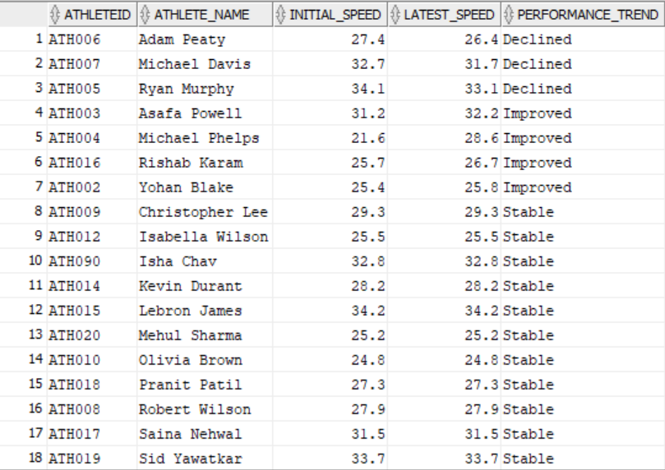

**Significance**: This can be useful for athletes, coaches and even sponsors to track their performance, accessing the effectiveness of training, team selection etc. This analysis is useful in events where performance is dependent on speed example: race, track and field.

**Query 2: Viewership Change of Athletes**

Compiles ranked viewership data for athletes during events from the Olympics dataset. ​  
The results offer insights into audience engagement and popularity among athletes across events​.

CREATE OR REPLACE VIEW viewership_vs_athlete AS

WITH RankedViewership AS (

SELECT

V.ViewershipID, V.ViewershipNumbers, V.ViewershipDate, V.ViewershipTime,

B.broadcastID, E.eventID, E.eventname, A.athleteID, A.fname,

RANK() OVER (

ORDER BY V.ViewershipNumbers DESC

) AS ViewerRank,

LAG(V.ViewershipNumbers) OVER (

ORDER BY V.ViewershipNumbers DESC

) AS PrevViewershipNumbers

FROM

VIEWERSHIP V

JOIN TELECAST T ON V.ViewershipID = T.ViewershipID

JOIN BROADCAST B ON T.broadcastID = B.broadcastID

JOIN BROADCAST_EVENTS BE ON B.broadcastID = BE.broadcastID

JOIN EVENTS_UPDATED E ON BE.eventID = E.eventID

JOIN MEDALS_UPDATED M ON E.eventID = M.eventID

JOIN ATHLETES_UPDATED A ON M.athleteID = A.athleteID

)

SELECT

R.eventname, A.Fname || ' ' || A.Lname AS "ATHLETE NAME", R.ViewershipDate, R.ViewerRank,

R.ViewershipNumbers AS "CURRENT VIEWERSHIP", R.PrevViewershipNumbers AS "PREVIOUS VIEWERSHIP",

R.ViewershipNumbers - R.PrevViewershipNumbers AS "VIEWERSHIP CHANGE"

FROM

RankedViewership R

JOIN ATHLETES_UPDATED A ON R.athleteID = A.athleteID

ORDER BY

R.ViewerRank;

SELECT * FROM viwership_vs_athlete;

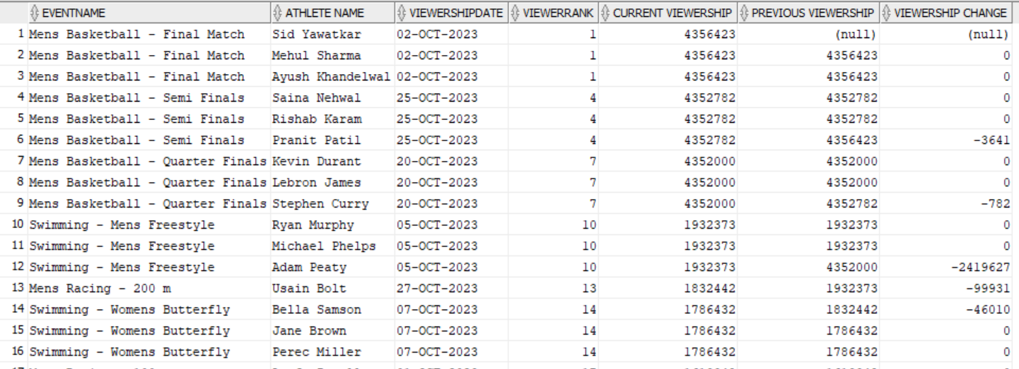

**Significance**: This query is useful for making marketing and sponsorship decisions, event planning, and broadcasting strategies. Negative viewership change defines a drop in viewership whereas positive means improvement.

**Query 3: Analyzing the Successive Triumphs**

This query identifies athletes who won in consecutive Olympic editions exactly four years apart and provides insights into athletes' consistent improvement in the Olympics across consecutive quadrennial events​.

DROP VIEW IF EXISTS athletes_consecutive_medals ;

CREATE OR REPLACE VIEW athletes_consecutive_medals AS

SELECT A.athleteID, A.Fname || ' ' || A.Lname as Athlete_Name, EXTRACT(YEAR FROM E1.year) AS First_Year,

EXTRACT(YEAR FROM E2.year) AS Second_Year

FROM ATHLETES_UPDATED A

INNER JOIN MEDALS_UPDATED M1 ON A.athleteID = M1.athleteID

INNER JOIN PLAYS_IN P1 ON A.athleteID = P1.athleteID

INNER JOIN EDITION E1 ON P1.editionid = E1.editionID

INNER JOIN MEDALS_UPDATED M2 ON A.athleteID = M2.athleteID

INNER JOIN PLAYS_IN P2 ON A.athleteID = P2.athleteID

INNER JOIN EDITION E2 ON P2.editionid = E2.editionID

WHERE EXTRACT(YEAR FROM E1.year) + 4 = EXTRACT(YEAR FROM E2.year)

AND E1.editionID <> E2.editionID

GROUP BY A.athleteID, A.Fname || ' ' || A.Lname, E1.year, E2.year

ORDER BY A.athleteID, EXTRACT(YEAR FROM E1.year)

;

SELECT * FROM athletes_consecutive_medals ;

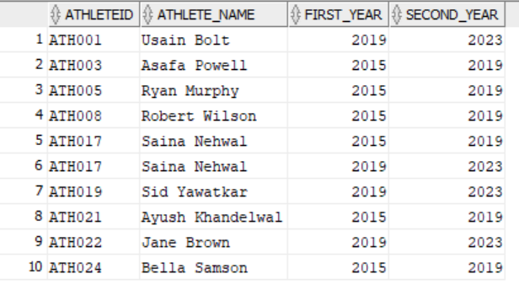

**Significance:** This type of analysis contributes to building the legacy of athletes by showcasing their sustained success. It emphasizes the longevity of an athlete's career. Coaches, sports scientists, and athletes themselves can derive valuable insights into the training and preparation strategies that contribute to success over multiple Olympic cycles.

## **Query 4: Evaluating Gender Representation**

This query calculates the male and female count in all Olympic editions and then calculates the male and female ratio. It provides valuable information about gender representation in the Olympic Games.

SELECT

TO_CHAR(year, 'YYYY') AS olympic_year,

COUNT(CASE WHEN gender = 'Male' THEN 1 END) AS male_count,

COUNT(CASE WHEN gender = 'Female' THEN 1 END) AS female_count,

COUNT(*) AS total_count,

ROUND(COUNT(CASE WHEN gender = 'Male' THEN 1 END) / COUNT(*) * 1.0, 2) AS male_ratio,

ROUND(COUNT(CASE WHEN gender = 'Female' THEN 1 END) / COUNT(*) * 1.0, 2) AS female_ratio

FROM ATHLETES_UPDATED JOIN plays_in on Athletes_updated.athleteid= plays_in.athleteid

JOIN Edition on plays_in.editionid= edition.editionid

WHERE year IS NOT NULL

GROUP BY TO_CHAR(year, 'YYYY')

ORDER BY olympic_year;

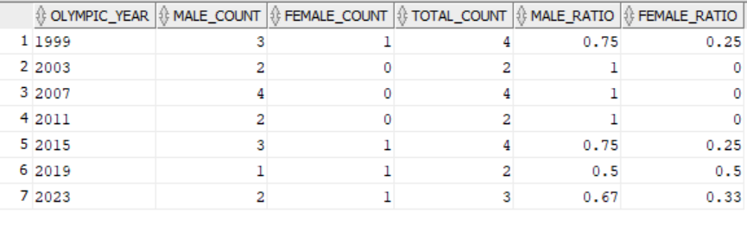

**Significance**: We have included data of Olympic editions (1999-2023). This type of query is useful in gender equality assessment, evaluating the impact of policies and initiatives aimed at promoting gender equality in sports and setting benchmarks for future goals.

## **Query 5: Ranking Olympic Events: Analyzing Total Viewership**

This query finds the total viewership numbers for a specific event and the result is arranged in descending order based on viewership to get the most viewed event.

DROP VIEW IF EXISTS viewership_across_events;

CREATE OR REPLACE VIEW viewership_across_events AS

SELECT eventname AS Event_Name, trim(to_char(SUM(viewershipnumbers),'999,999,999')) AS Total_Viewership

FROM events_updated a

JOIN BROADCAST_EVENTS b ON a.eventID = b.eventID

JOIN BROADCAST c ON c.broadcastID = b.broadcastID

JOIN TELECAST d ON c.broadcastID = d.broadcastID

JOIN VIEWERSHIP e ON e.viewershipID = d.viewershipID

GROUP BY eventname

ORDER BY Total_Viewership DESC

;

SELECT * FROM viewership_across_events ;

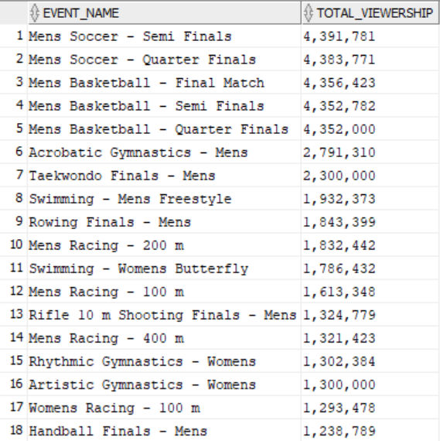

**Significance:** This query helps in identifying and recognizing the most popular or highly viewed event. This information is valuable for event organizers, broadcasters, sponsors, and sports enthusiasts, as it sheds light on the events that capture the largest audience.

## **Query 6 : Top Performers: Identifying Athletes with the Highest Medal Count**

This query finds athletes with the Highest Medal Count and the country they belong to.

DROP VIEW IF EXISTS athletes_medal_count ;

CREATE OR REPLACE VIEW athletes_medal_count AS

SELECT A.Fname || ' ' || A.Lname AS Athlete_Name, A.country, COUNT(M.medalID) AS medal_count

FROM ATHLETES_UPDATED A

JOIN MEDALS_UPDATED M ON A.athleteID = M.athleteID

GROUP BY A.Fname || ' ' || A.Lname, A.country

ORDER BY medal_count DESC

;

SELECT * FROM athletes_medal_count ;

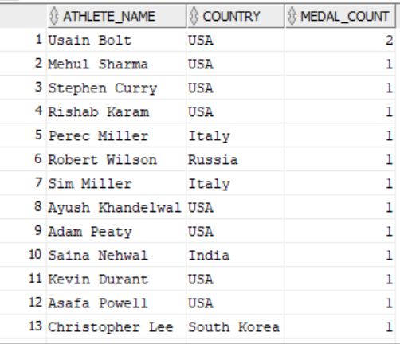

**Significance**: Knowing which athletes have the highest medal count and the country they represent fosters a sense of national pride and identity. Athletes with a high medal count are likely to attract endorsements and sponsorships. Their success enhances their marketability, making them valuable ambassadors for brands seeking to associate with excellence and achievement in sports.

**Query 7:** Analyzing Event Attendance Trends

## This query checks the attendance of audience at the events and by using lag extracts the previous attendance and checks the change in attendance.

DROP VIEW IF EXISTS event_popularity ;

CREATE OR REPLACE VIEW event_popularity AS

SELECT *

FROM

(

SELECT E.eventname, E.eventdate, E.attendance,

COALESCE(LAG(E.attendance) OVER (PARTITION BY E.eventname ORDER BY E.eventdate),0) as Previous_Editions_Attendance,

COALESCE(E.attendance - LAG(E.attendance) OVER (PARTITION BY E.eventname ORDER BY E.eventdate),0) as Attendance_Change

FROM EVENTS_UPDATED E

)

WHERE Previous_Editions_Attendance != 0

;

SELECT * FROM event_popularity ;

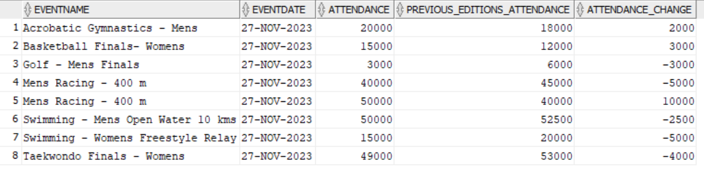

**Significance**: By checking attendance and analyzing changes over time, the query provides a means to assess audience engagement. Understanding attendance trends helps event organizers and stakeholders gauge the overall interest and appeal of the events. It helps in event popularity assessment and understanding seasonal patterns.

**Query 8**: **Coaching Excellence**

This query lists the top Performing Coaches Based on Athletes' Improvements in terms of average speed gains.

DROP VIEW IF EXISTS coaches_effectiveness ;

CREATE OR REPLACE VIEW coaches_effectiveness AS

SELECT *

FROM

(

SELECT C.coachname, A.fname || ' ' || A.lname AS athletename , AVG(PD.speed) OVER (PARTITION BY C.coachname) as AvgSpeedGains

FROM COACH C

JOIN PERFORMANCE_DETAILS_UPDATED PD ON C.coachID = PD.coachID

JOIN ATHLETES_UPDATED A ON PD.athleteID = A.athleteId

ORDER BY AvgSpeedGains DESC

)

GROUP BY coachname, athletename, AvgSpeedGains

;

SELECT * FROM coaches_effectiveness ;

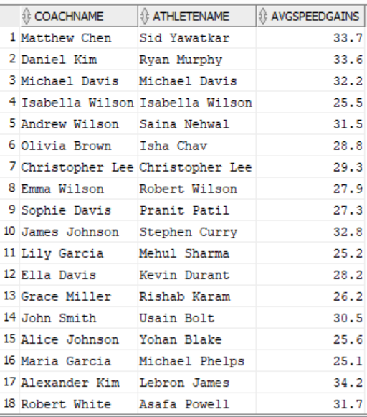

**Significance**: The query highlights and recognizes coaches who have been successful in improving the performance of their athletes. Analyzing the top-performing coaches allows sports organizations, coaching staff, and individual coaches to identify successful coaching strategies and improve coaching programs.

## **Query 9: Unveiling Doping Incidents**

This query list out the Doping Results and Athlete Information and sanctions applied.

DROP VIEW IF EXISTS athlete_doping ;

CREATE OR REPLACE VIEW athlete_doping AS

SELECT A.athleteId, A.fname || ' ' || A.lname AS AthleteName, D.dopingstatus, D.sanctions

FROM ATHLETES_UPDATED A

JOIN INDULGES_IN I ON A.athleteId = I.athleteID

JOIN DOPING_RESULTS D ON I.dopingresultID = D.dopingresultID

GROUP BY A.athleteId, A.fname || ' ' || A.lname, D.dopingstatus, D.sanctions

ORDER BY DOPINGSTATUS

;

SELECT * FROM athlete_doping ;

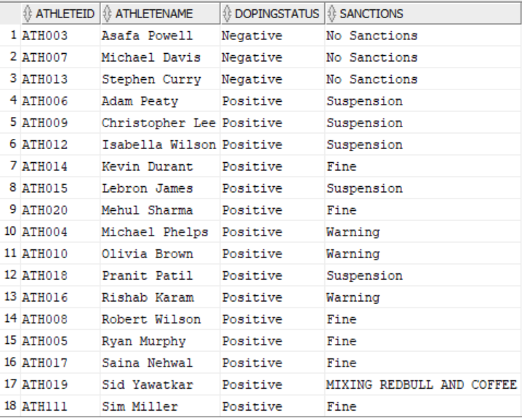

**Significance:** It is profound in the context of maintaining the integrity, fairness, and ethical standards of sports. By disclosing doping results, it ensures that athletes who engage in prohibited substances or methods are held accountable, preventing an unfair advantage over clean competitors. It is helpful in earning public confidence and planning anti doping policies.

## **Query 10:** Unlocking Success: A Comprehensive Exploration of Event-Specific Sponsorship Details and their Impact on Viewership

Sponsorship Details by Event to find out which sponsors have maximum viewership and how much. Showing sponsor their type, category and name of the event in which they received that viewership.

DROP VIEW IF EXISTS event_sponsorship ;

CREATE OR REPLACE VIEW event_sponsorship AS

SELECT S.sponsorshipname as Sponsor ,S.sponsorshiptype, S.sponsorshipcategory,E.eventname,

trim(to_char(SUM(viewershipnumbers),'999,999,999')) AS Total_Viewership

FROM EVENTS_UPDATED E

JOIN FINANCED_AT F ON E.eventID = F.eventID

JOIN SPONSORSHIP S ON F.sponsorshipID = S.sponsorshipID

JOIN BROADCAST_EVENTS b ON e.eventID = b.eventID

JOIN BROADCAST c ON c.broadcastID = b.broadcastID

JOIN TELECAST d ON c.broadcastID = d.broadcastID

JOIN VIEWERSHIP v ON v.viewershipID = d.viewershipID

GROUP BY E.eventname,S.sponsorshipname, S.sponsorshiptype, S.sponsorshipcategory

ORDER BY Total_Viewership DESC

;

SELECT * FROM event_sponsorship ;

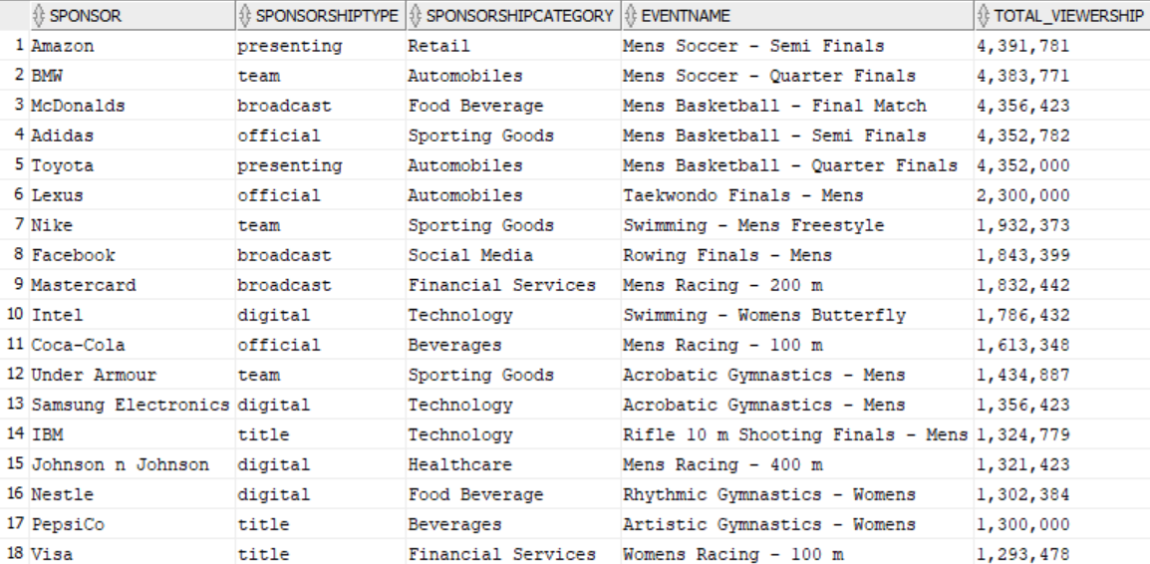

**Significance:** The query allows sponsors to assess the impact of their sponsorship investments by linking them to viewership metrics. Sponsors can identify which events generate the most visibility, helping them make informed decisions, and assisting sponsors in measuring return on investment (ROI).

## **Query 11: Speed Vs Success**

This query find the average speed of athletes who participated in events and won medals based in particular sports. We are testing the hypothesis does high speed means more winning chances

CREATE OR REPLACE VIEW speed_vs_winning_chance AS

WITH MedalInfo AS (

SELECT

A.athleteID,

COUNT(M.medal_type) AS NumMedals,

AVG(PD.speed) AS AvgSpeed

FROM

ATHLETES_UPDATED A

JOIN

PERFORMANCE_DETAILS_UPDATED PD ON A.athleteID = PD.athleteID

LEFT JOIN

MEDALS_UPDATED M ON A.athleteID = M.athleteID

JOIN

EVENTS_UPDATED E ON M.eventID = E.eventID

WHERE

E.EventCategory = 'Track and Field' -- Replace 'your_swimming_sport_id' with the actual ID for the "Swimming" sports category

GROUP BY

A.athleteID

)

SELECT

MI.athleteID,

A.fname,

A.lname,

MI.NumMedals,

MI.AvgSpeed

FROM

ATHLETES_UPDATED A

JOIN

MedalInfo MI ON A.athleteID = MI.athleteID;

SELECT * FROM speed_vs_winning_chance;

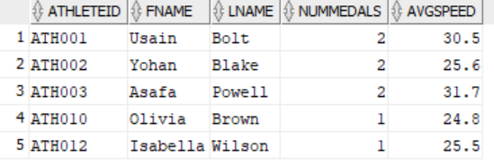

**Significance:** Athletes and coaches can use the results to gain strategic insights into the relationship between speed and winning in their respective sports. Coaches can make more informed, data-driven decisions by incorporating the findings into their coaching methodologies. If a strong correlation is identified, coaches may prioritize speed-focused training regimes to enhance athletes' competitive edge.

## **Query 12:** Analyzing Athlete Viewership Dynamics

This query calculates the viewership of athletes in previous event and current event. It also shows the difference between both viewership to showcase viewership change.

CREATE OR REPLACE VIEW viewership_trends AS

WITH RankedViewership AS (

SELECT

V.ViewershipID, V.ViewershipNumbers, V.ViewershipDate, V.ViewershipTime,

B.broadcastID, E.eventID, E.eventname, A.athleteID, A.fname,

RANK() OVER (

PARTITION BY A.Fname || ' ' || A.Lname ORDER BY V.ViewershipNumbers DESC

) AS ViewerRank,

LAG(V.ViewershipNumbers) OVER (

ORDER BY V.ViewershipNumbers DESC

) AS PrevViewershipNumbers

FROM

VIEWERSHIP V

JOIN TELECAST T ON V.ViewershipID = T.ViewershipID

JOIN BROADCAST B ON T.broadcastID = B.broadcastID

JOIN BROADCAST_EVENTS BE ON B.broadcastID = BE.broadcastID

JOIN EVENTS_UPDATED E ON BE.eventID = E.eventID

JOIN MEDALS_UPDATED M ON E.eventID = M.eventID

JOIN ATHLETES_UPDATED A ON M.athleteID = A.athleteID

)

SELECT

R.eventname, A.Fname || ' ' || A.Lname AS "ATHLETE NAME", R.ViewershipDate, R.ViewerRank,

R.ViewershipNumbers AS "CURRENT VIEWERSHIP", R.PrevViewershipNumbers AS "PREVIOUS VIEWERSHIP",

R.ViewershipNumbers - R.PrevViewershipNumbers AS "VIEWERSHIP CHANGE"

FROM

RankedViewership R

JOIN ATHLETES_UPDATED A ON R.athleteID = A.athleteID

ORDER BY

R.ViewerRank

;

SELECT * FROM viewership_trends;

**Significance:** It provides insights into the evolving popularity and audience engagement of athletes across different events. his information can be valuable for various stakeholders, including event organizers, sponsors, and athletes themselves, as it helps in understanding the impact of factors such as performance, media coverage, and public interest on an athlete's appeal.

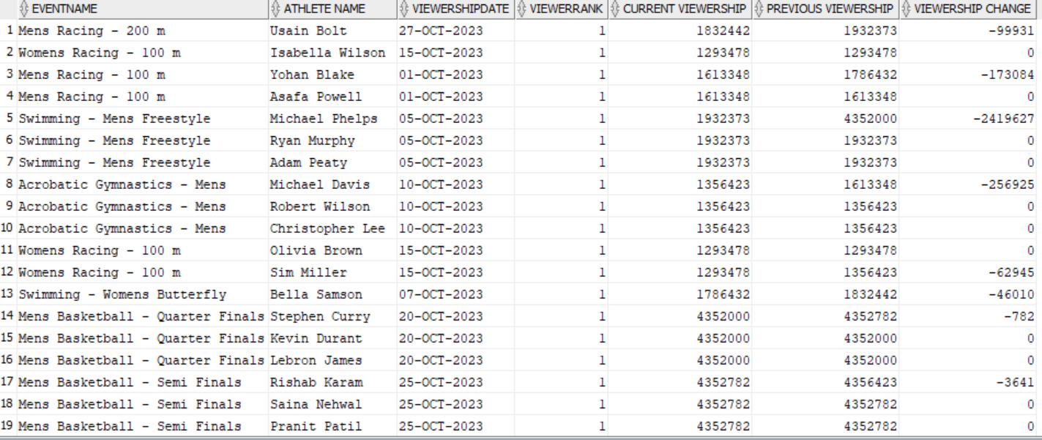

## **Query 13:** Evolution of Excellence marked by total medal count

This query calculated the cumulative Medal Count Over Time for Each Country and date recorded.

DROP VIEW IF EXISTS country_medals ;

CREATE OR REPLACE VIEW country_medals AS

SELECT A.country, PD.daterecorded, COUNT(PD.medal) OVER (PARTITION BY A.country ORDER BY PD.daterecorded) as CumulativeMedals

FROM PERFORMANCE_DETAILS_UPDATED PD

JOIN ATHLETES_UPDATED A ON PD.athleteID = A.athleteId

ORDER BY 3 DESC

;

SELECT * FROM country_medals ;

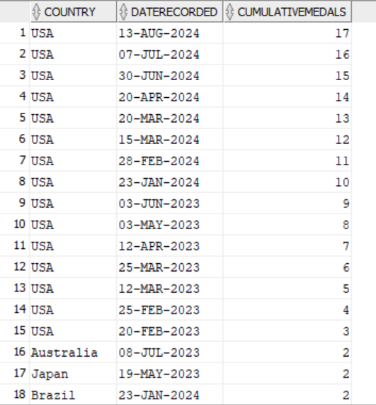

**Significance** : The query enables a comprehensive historical analysis of countries' performances in sports events over time, helps identify long-term trends and patterns in countries' sporting achievements. Understanding the historical cumulative medal count allows for more informed resource allocation by governments and sports organizations

## 

## **Query 14:** Time-Based Event Sequencing: Retrieving Previous and next Events

This query helps to retrieve information about the previous and next events based on the event date. It shows eventID, event name, date, next event and previous event.

CREATE OR REPLACE VIEW previous_and_next_events AS

SELECT

eventID,

eventname,

year,

LEAD(eventname) OVER (ORDER BY year) AS nextEvent,

LAG(eventname) OVER (ORDER BY year) AS previousEvent

FROM

EVENTS_UPDATED;

COMMIT;

SELECT * FROM previous_and_next_events;

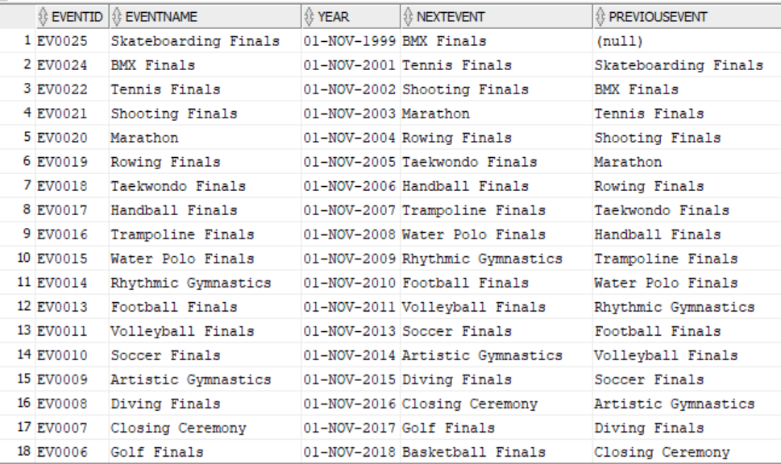

**Significance:** The query facilitates efficient event navigation and organization by providing information about the chronological order of events. The query assists event organizers in strategic planning for future events. Understanding the timeline and sequence of events enables organizers to plan dates, venues, and themes strategically.

## **Query 15** Gold Medal Excellence: Identifying Top-Performing Athletes

This query helps to retrieve top-performing athletes based on the number of gold medals, showing the athleteID, athleteName and count of the gold medals.

CREATE OR REPLACE VIEW top_performing_athletes AS

SELECT Athletes_updated.AthleteID, ATHLETES_updated.fname || ' '|| ATHLETES_updated.lname AS athletename, COUNT(Medals_updated.medal_Type) AS Gold_Medals

FROM Athletes_UPDATED

JOIN Performance_Details_Updated ON Athletes_updated.AthleteID = Performance_Details_updated.AthleteID

JOIN Medals_UPDATED ON Performance_Details_Updated.AthleteID = Medals_updated.AthleteID

WHERE medal_Type = 'Gold'

GROUP BY Athletes_updated.AthleteID, Fname, Lname -- Include non-aggregated columns in the GROUP BY

ORDER BY Gold_Medals DESC

FETCH FIRST 10 ROWS ONLY;

SELECT * FROM top_performing_athletes;

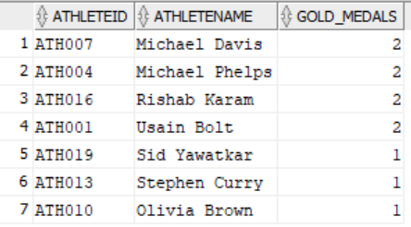

**Significance:** The query allows for the recognition of athletes who have achieved excellence by winning a significant number of gold medals. Athletes with a significant number of gold medals are often more marketable. The query results can guide marketing professionals and sponsors in identifying athletes for endorsements

## **Query 16** Gender Diversity in Athletics

Calculate the Percentage of Male and Female Athletes. Showing male and female count.

CREATE OR REPLACE VIEW gender_ratio AS

SELECT

Gender,

COUNT(*) AS AthleteCount,

COUNT(*) * 100 / (SELECT COUNT(*) FROM Athletes)) AS Percentage

FROM

Athletes_Updated;

GROUP BY

Gender;

SELECT * FROM gender_ratio;

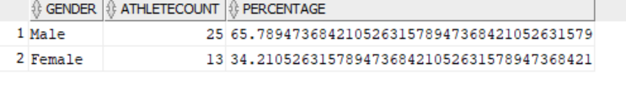

**Significance:** The query allows for an analysis of gender representation in sports. Calculating the percentage of male and female athletes provides insights into the overall balance or imbalance in participation between genders.

**Chapter 5**

## **5.1 Triggers and Procedures**

## **Trigger 1**

The apply_ticket_discount trigger is designed to automatically apply discounts to ticket purchases based on the ticket type and quantity. It calculates the discounted price based on the listed price and quantity and applies the appropriate discount for General Admission and Regular tickets. It also checks for the maximum ticket quantity allowed and raises an error if the specified quantity exceeds the limit.

This trigger is helpful for two reasons:

* **Automatic Discount Application:** It automates the discount calculation and application process, ensuring that customers receive the correct discounts without manual intervention.
* **Error Handling:** It handles potential errors like exceeding the maximum ticket quantity and raises appropriate error messages to prevent invalid transactions.

CREATE OR REPLACE TRIGGER apply_ticket_discount

BEFORE INSERT ON TICKET_SALE_UPDATED

FOR EACH ROW

DECLARE

v_discountedPrice DECIMAL(10, 2);

v_ticketType VARCHAR2(30);

v_ticketQuantity NUMBER(4, 2);

v_listedPrice DECIMAL(10, 2);

BEGIN

SELECT ticketType, listedPrice

INTO v_ticketType, v_listedPrice

FROM TICKET_CATEGORY_UPDATED

WHERE ticketCategoryID = :NEW.ticketcategoryID;

IF v_listedPrice IS NOT NULL THEN

v_discountedPrice := v_listedPrice * :NEW.ticketQuantity;

IF v_ticketType IN ('General Admission','Regular') THEN

IF :NEW.ticketQuantity <= 5 THEN

v_discountedPrice := v_discountedPrice;

ELSIF :NEW.ticketQuantity <= 10 THEN

v_discountedPrice := v_discountedPrice * 0.95;

ELSIF :NEW.ticketQuantity <= 20 THEN

v_discountedPrice := v_discountedPrice * 0.85;

ELSE

RAISE_APPLICATION_ERROR(-20001, 'Cannot purchase more than 20 tickets');

END IF;

ELSE

v_discountedPrice := v_listedPrice * :NEW.ticketQuantity;

END IF;

:NEW.purchasePrice := v_discountedPrice;

END IF;

END;

/

## **Trigger 2**

The main functionality of the trigger log_athlete_changes is to track changes to the ATHLETES_UPDATED table. The trigger is fired whenever a row is inserted, updated, or deleted from the table.

This trigger is helpful for two reasons:

* **Data Change Tracking:** The trigger effectively captures all modifications to the ATHLETES_UPDATED table, including insertions, updates, and deletions. This ensures that there is a complete record of every change made to the table data.
* **Detailed Logging:** The trigger not only logs the operation type but also provides granular details about the change, including the specific attribute that was modified, the old value, the new value, and the timestamp of the change.

CREATE OR REPLACE TRIGGER log_athlete_changes

BEFORE DELETE OR INSERT OR UPDATE ON ATHLETES_UPDATED

FOR EACH ROW

DECLARE

-- Declare variables for the operation type, attribute name, old value, and updated value

v_operation VARCHAR2(10);

v_attribute_name VARCHAR2(30);

v_old_value VARCHAR2(255);

v_updated_value VARCHAR2(255);

BEGIN

-- Determine the operation type

IF DELETING THEN

v_operation := 'DELETE';

v_attribute_name := 'athleteID';

v_old_value := :OLD.athleteID;

v_updated_value := NULL;

ELSIF INSERTING THEN

v_operation := 'INSERT';

v_attribute_name := 'athleteID';

v_old_value := NULL;

v_updated_value := :NEW.athleteID;

ELSIF UPDATING THEN

v_operation := 'UPDATE';

-- Set attribute name, old value, and updated value based on updated column

CASE

WHEN :OLD.country IS NOT NULL AND :NEW.country != :OLD.country THEN

BEGIN

v_attribute_name := 'country';

v_old_value := :OLD.country;

v_updated_value := :NEW.country;

END;

WHEN :OLD.gender IS NOT NULL AND :NEW.gender != :OLD.gender THEN

BEGIN

v_attribute_name := 'gender';

v_old_value := :OLD.gender;

v_updated_value := :NEW.gender;

END;

WHEN :OLD.Fname IS NOT NULL AND :NEW.Fname != :OLD.Fname THEN

BEGIN

v_attribute_name := 'Fname';

v_old_value := :OLD.Fname;

v_updated_value := :NEW.Fname;

END;

WHEN :OLD.Lname IS NOT NULL AND :NEW.Lname != :OLD.Lname THEN

BEGIN

v_attribute_name := 'Lname';

v_old_value := :OLD.Lname;

v_updated_value := :NEW.Lname;

END;

WHEN :OLD.DOB IS NOT NULL AND :NEW.DOB != :OLD.DOB THEN

BEGIN

v_attribute_name := 'DOB';

v_old_value := :OLD.DOB;

v_updated_value := :NEW.DOB;

END;

WHEN :OLD.height IS NOT NULL AND :NEW.height != :NEW.height THEN

BEGIN

v_attribute_name := 'height';

v_old_value := :OLD.height;

v_updated_value := :NEW.height;

END;

WHEN :OLD.weight IS NOT NULL AND :NEW.weight != :NEW.weight THEN

BEGIN

v_attribute_name := 'weight';

v_old_value := :OLD.weight;

v_updated_value := :NEW.weight;

END;

ELSE

v_attribute_name := NULL;

v_old_value := NULL;

v_updated_value := NULL;

END CASE;

END IF;

-- Insert information into the audit log table if an attribute value has changed

IF v_attribute_name IS NOT NULL THEN

INSERT INTO AUDIT_LOG (operationType, tableName, columnName, oldValue, newValue, dateChanged)

VALUES (v_operation, 'ATHLETES', v_attribute_name, v_old_value, v_updated_value, CURRENT_TIMESTAMP);

END IF;

END;

/

## **Procedure 1**

The procedure AthletePerformanceSummary takes an athlete ID as input and retrieves the athlete's performance details from the PERFORMANCE_DETAILS_UPDATED table. It then calculates the athlete's total medal count, best record value, and best record type. Finally, it prints the athlete's information to the screen.

This procedure is helpful for several reasons:

* It provides a quick and easy way to view an athlete's overall performance.
* It can be used to identify athletes who are excelling in their sport.
* It can be used to track an athlete's progress over time.

CREATE OR REPLACE PROCEDURE AthletePerformanceSummary (p_athleteID IN PERFORMANCE_DETAILS_UPDATED.athleteID%TYPE)

IS

v_Fname VARCHAR2(50);

v_Lname VARCHAR2(50);

v_gender VARCHAR2(10);

v_height NUMBER(5, 2);

v_weight NUMBER(5, 2);

v_medalCount INT := 0;

v_bestRecordValue RECORDS.recordValue%TYPE := 0;

v_bestRecordType RECORDS.recordType%TYPE := '';

v_bestDateRecorded PERFORMANCE_DETAILS_UPDATED.DATERECORDED%TYPE := NULL;

CURSOR c_performance IS

SELECT ATHLETES_UPDATED.Fname, ATHLETES_UPDATED.Lname, ATHLETES_UPDATED.gender, ATHLETES_UPDATED.height,

ATHLETES_UPDATED.weight,PERFORMANCE_DETAILS_UPDATED.medal, RECORDS.recordValue, RECORDS.recordType,

PERFORMANCE_DETAILS_UPDATED.DATERECORDED

FROM ATHLETES_UPDATED

JOIN PERFORMANCE_DETAILS_UPDATED ON ATHLETES_UPDATED.athleteID = PERFORMANCE_DETAILS_UPDATED.athleteID

LEFT JOIN ATHLETE_RECORDS ON ATHLETES_UPDATED.athleteID = ATHLETE_RECORDS.athleteID

LEFT JOIN RECORDS ON ATHLETE_RECORDS.recordID = RECORDS.recordID

WHERE ATHLETES_UPDATED.athleteID = p_athleteID;

BEGIN

-- Loop through performances and athlete details

FOR record IN c_performance LOOP

-- Assign athlete details from the first record

IF v_Fname IS NULL THEN

v_Fname := record.Fname;

v_Lname := record.Lname;

v_gender := record.gender;

v_height := record.height;

v_weight := record.weight;

END IF;

-- Count medals

IF record.medal = 'Yes' THEN

v_medalCount := v_medalCount + 1;

END IF;

-- Determine best record

IF record.recordValue > v_bestRecordValue THEN

v_bestRecordValue := record.recordValue;

v_bestRecordType := record.recordType;

v_bestDateRecorded := record.DATERECORDED; -- Corrected column name

END IF;

END LOOP;

-- Output results

IF v_Fname IS NOT NULL THEN

DBMS_OUTPUT.PUT_LINE('Athlete: ' || v_Fname || ' ' || v_Lname);

DBMS_OUTPUT.PUT_LINE('Gender: ' || v_gender);

DBMS_OUTPUT.PUT_LINE('Height: ' || v_height || ' cm');

DBMS_OUTPUT.PUT_LINE('Weight: ' || v_weight || ' kg');

DBMS_OUTPUT.PUT_LINE('Total Medals: ' || v_medalCount);

DBMS_OUTPUT.PUT_LINE('Best Record Type: ' || v_bestRecordType);

DBMS_OUTPUT.PUT_LINE('Best Record Value: ' || v_bestRecordValue);

DBMS_OUTPUT.PUT_LINE('Date Recorded: ' || v_bestDateRecorded);

ELSE

DBMS_OUTPUT.PUT_LINE('No data found for athlete ID: ' || p_athleteID);

END IF;

END AthletePerformanceSummary;

/

## **Procedure 2**

This procedure is helpful in maintaining the relationship between events and broadcasts. It ensures that events are not assigned to multiple broadcasts and prevents invalid assignments. It also serves as a centralized point for assigning events to broadcasts, making it easier to manage and track these assignments.

CREATE OR REPLACE PROCEDURE AssignEventToBroadcast(

eventID_in IN EVENTS_UPDATED.eventID%TYPE,

broadcastID_in IN BROADCAST.broadcastID%TYPE

) IS

v_count NUMBER;

BEGIN

-- Check if the event is already assigned to the broadcast

SELECT COUNT(*)

INTO v_count

FROM BROADCAST_EVENTS

WHERE broadcastID = broadcastID_in AND eventID = eventID_in;

-- If not assigned, then create a new assignment

IF v_count = 0 THEN

INSERT INTO BROADCAST_EVENTS (eventID, broadcastID)

VALUES (eventID_in, broadcastID_in);

ELSE

RAISE_APPLICATION_ERROR(-20002, 'This event is already assigned to the specified broadcast.');

END IF;

END AssignEventToBroadcast;

/

**Chapter 6**

## **6.1 User Interface**

Before delving into the user walkthrough for our web application, i would like to give out the existing credentials to access the application.

Link : [Olympics](http://54.218.32.166/olympics)

Login: pranit

Password: pranit

After the great work done on the backend side of things, including the logical, physical, and conceptual design of our database we had to have a platform to showcase the results/outcome of our project. A simple yet effective user interface was something which was the best way to do that.

We had free hand to choose any web development stack to build the UI, as .NET and HTML/CSS had an already chalked out documentation on the D2L page, we went ahead with it.

Our UI was divided into 5 main components, which are listed below.

1. Login Page
2. Registration Page
3. Home Page
4. Tables Menu Page
5. Insights Page

## **LOGIN PAGE:**

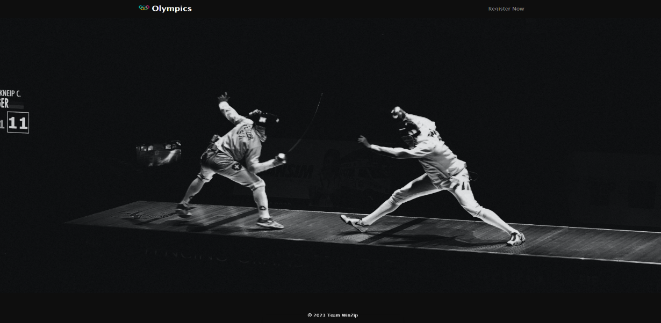

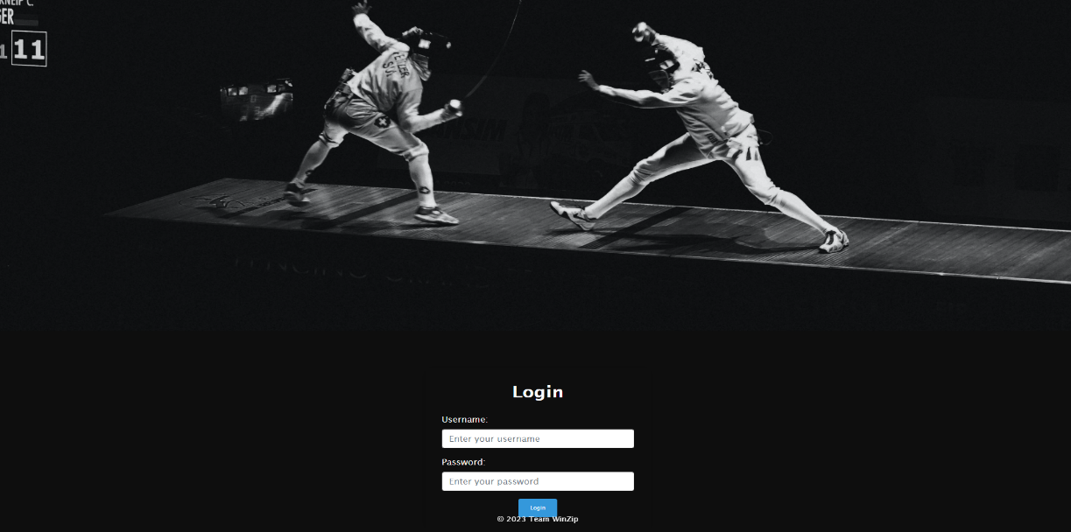

Login Page is what a user will land on when accessing the web application.

We tried to keep the layout very simple and yet functional with a navbar on top with a REGISTER NOW option for a new user to register themselves to use the application.

With a “Login” form which requires the user to put in valid credentials, we also included a functionality to authenticate the credentials in the backend thus only when the credentials match with one stored in the backend only then application can be accessed further.

1. **REGISTRATION PAGE**

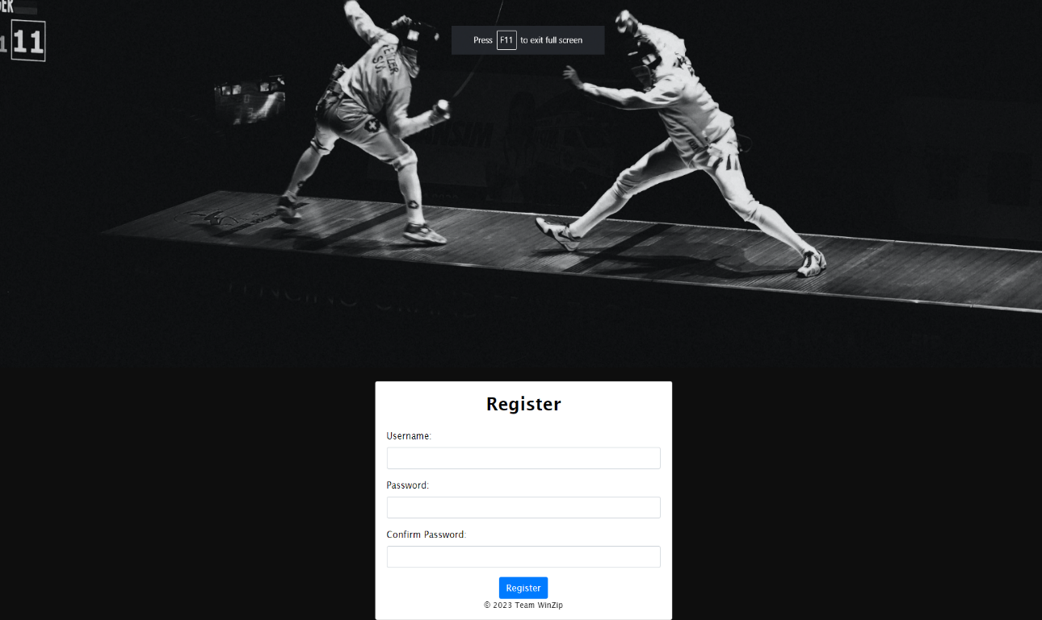

* Registration Page is for new users to get themselves registered in the application.
* A form is provided to get the username and password from the user, there’s also a basic constraint which checks whether the password and the confirm password inputs.
* Once registered the page redirects user to the login page to get itself authenticated before accessing the application.

1. **TABLES MENU PAGE**

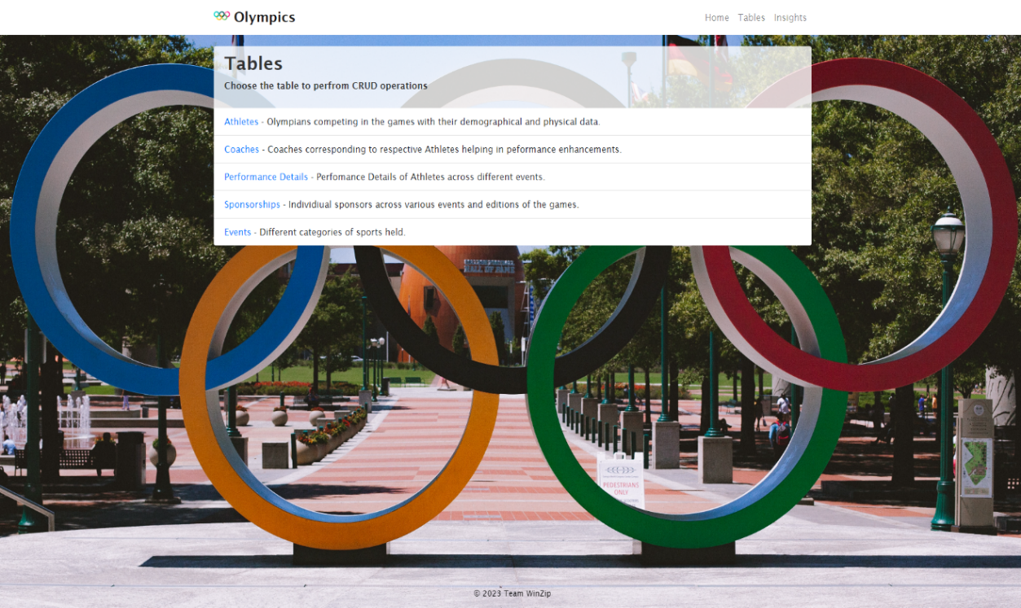

The tables menu page is where the user would find all the tables in the database (adhering with the project requirements and guidelines we included 5 most relevant tables on the page) to perform CRUD operations.

Along with a brief description of the tables, links are provided to access the data in the tables.

* 1. **Athletes**

There are 2 kinds of views offered to the user, one of which is the **GRID VIEW**

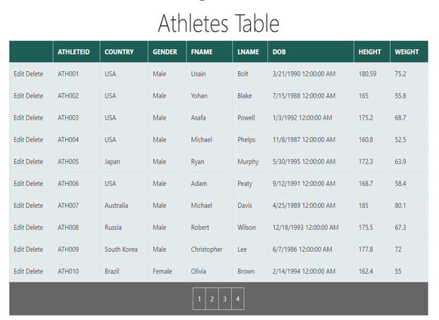

In grid view the data in the table is displayed with options to edit and delete the row specific data. Insert functionality is not provided in this view. We chose the table to be paged and allowed sorting based on columns.

The second view is the **DETAILED VIEW.**

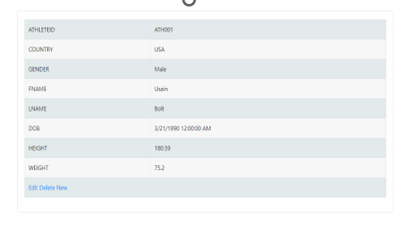

This view gave the option of inserting data in the tables along with deletion and update option. To insert new row of data in the table this form will be displayed on the UI.

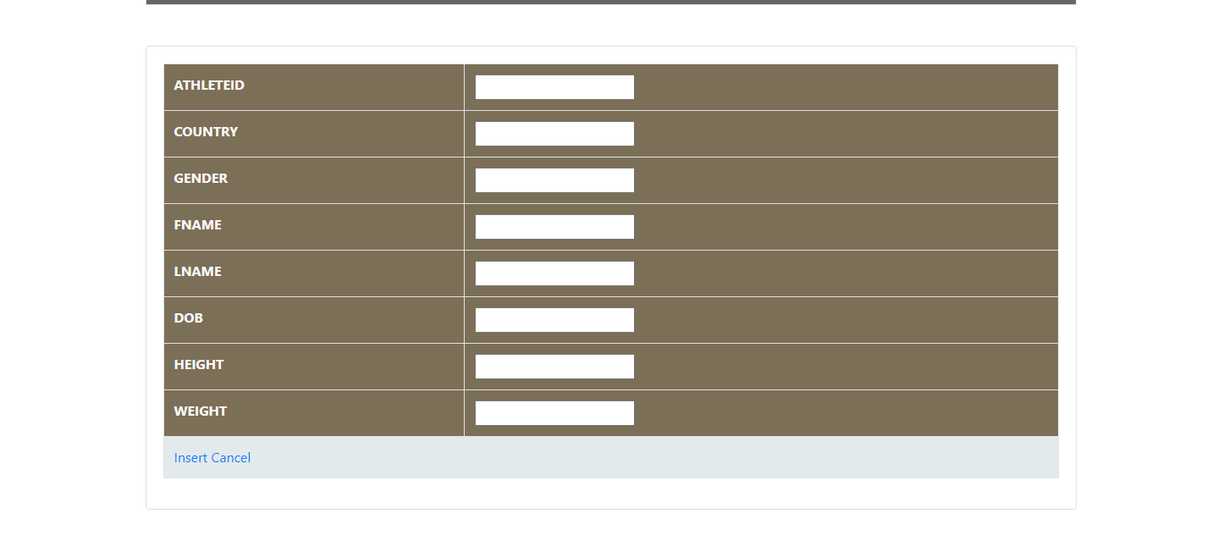

Same functionalities and formats are followed by rest of the tables.

* 1. **Coaches**

Similar 2 views are offered to the user, first of which is **GRID VIEW**.

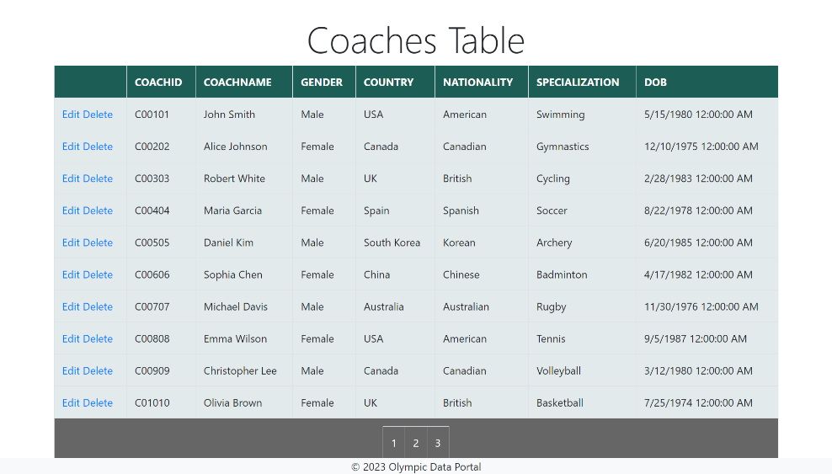

In grid view the data in the table is displayed with options to edit and delete the row specific data. Insert functionality is not provided in this view. We chose the table to be paged and allowed sorting based on columns.

The second view is the **DETAILED VIEW**.

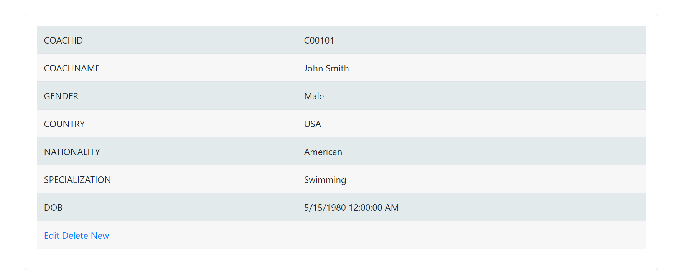

This view gave the option of inserting data in the tables along with deletion and update option. To insert new row of data in the table this form will be displayed on the UI.

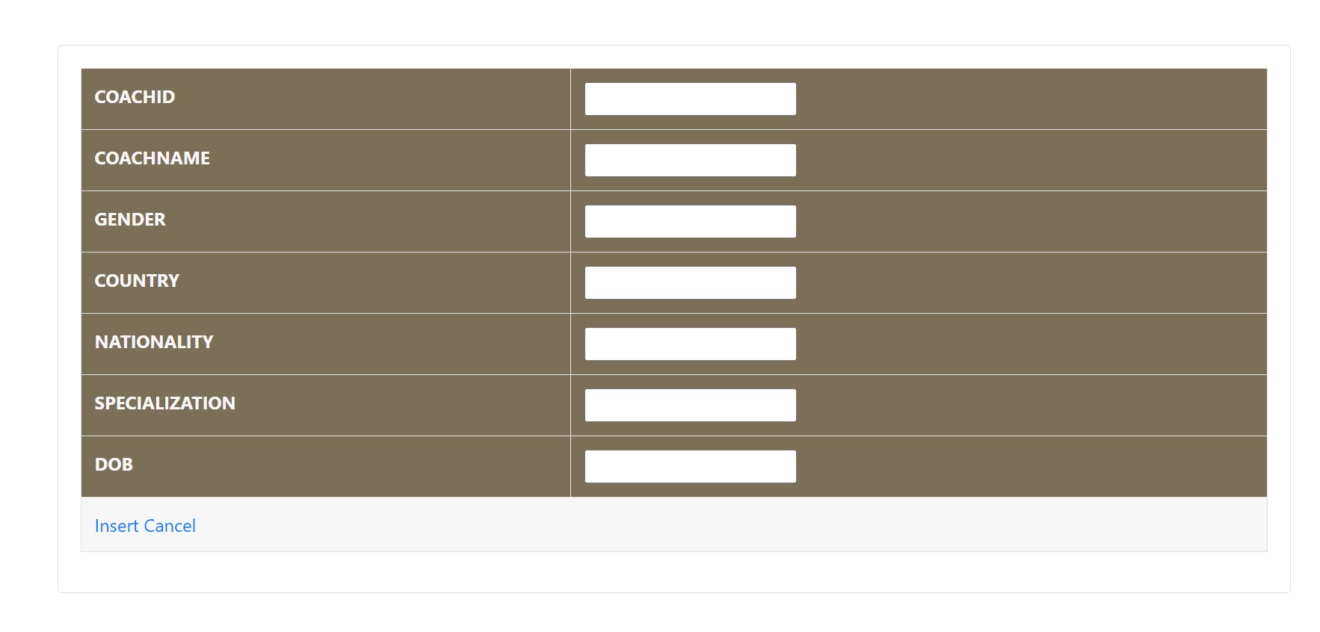

* 1. **Performance Details**

There are 2 kinds of views offered to the user, one of which is the **GRID VIEW**

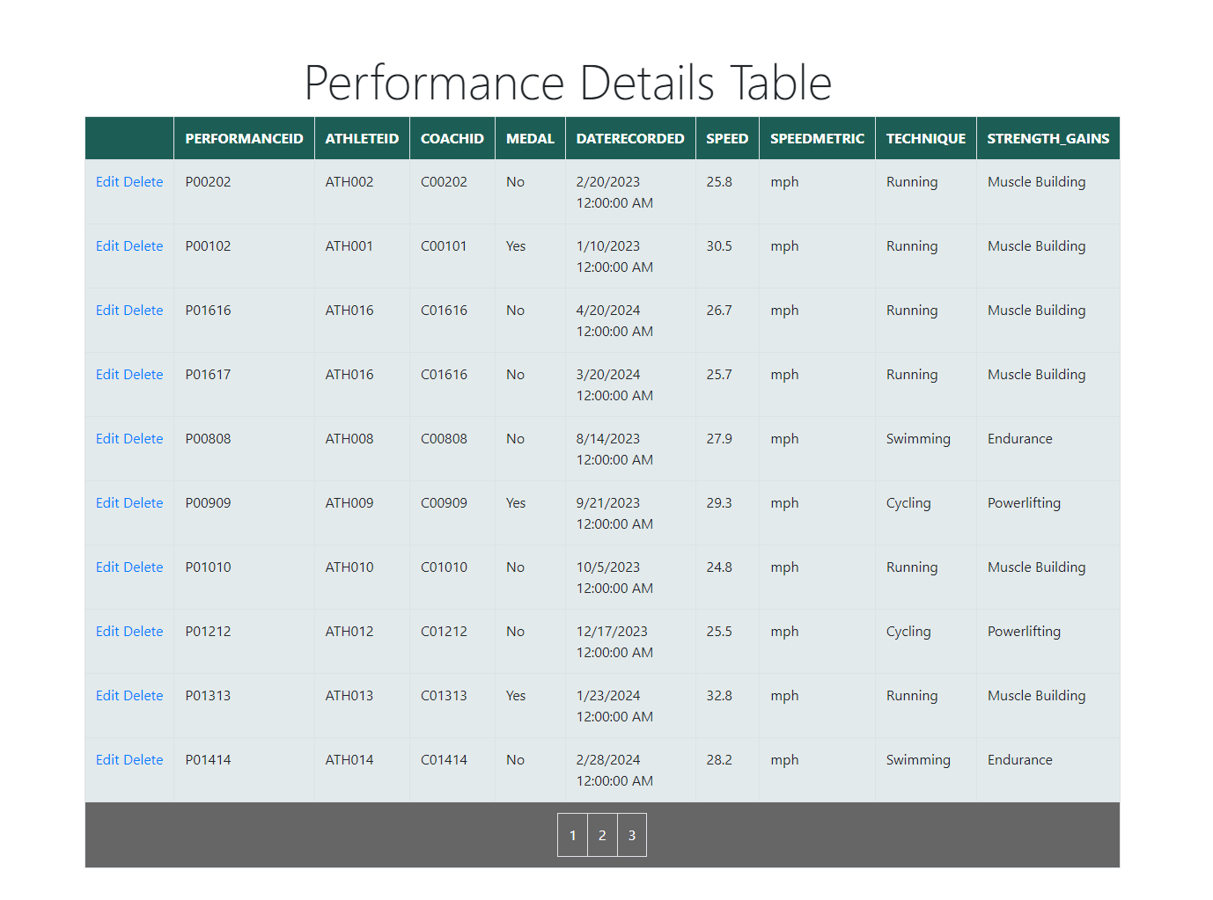

The second view is the **DETAILED VIEW**.

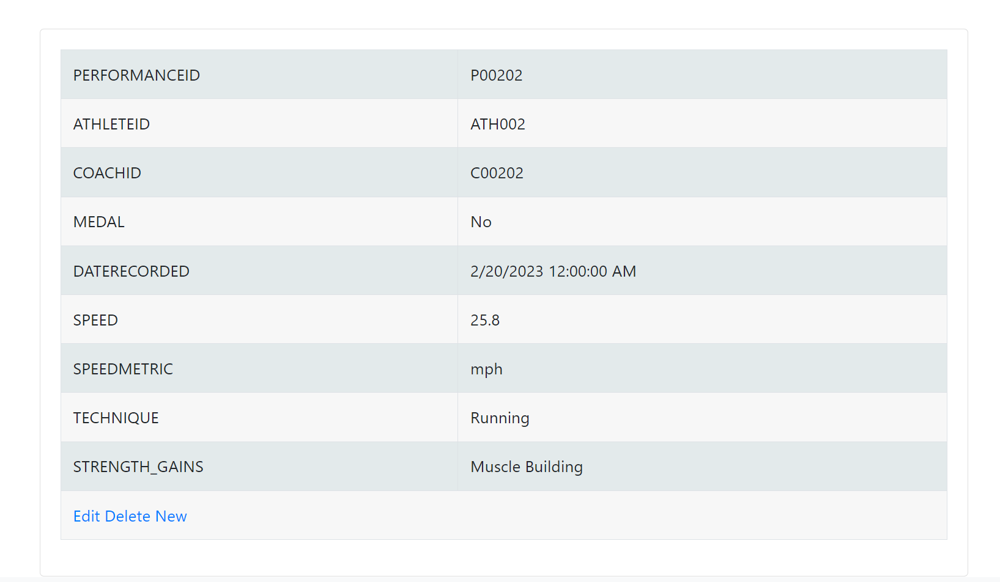

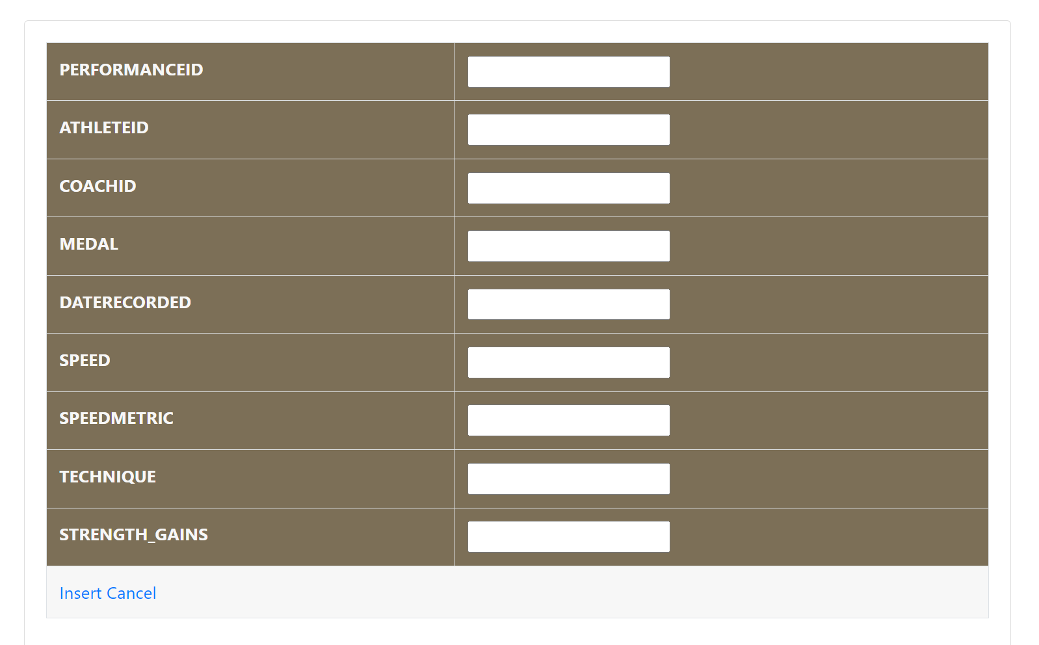This view gave the option of inserting data in the tables along with deletion and update option. To insert new row of data in the table this form will be displayed on the UI.

* 1. **Sponsorships**

There are 2 kinds of views offered to the user, one of which is the **GRID VIEW**

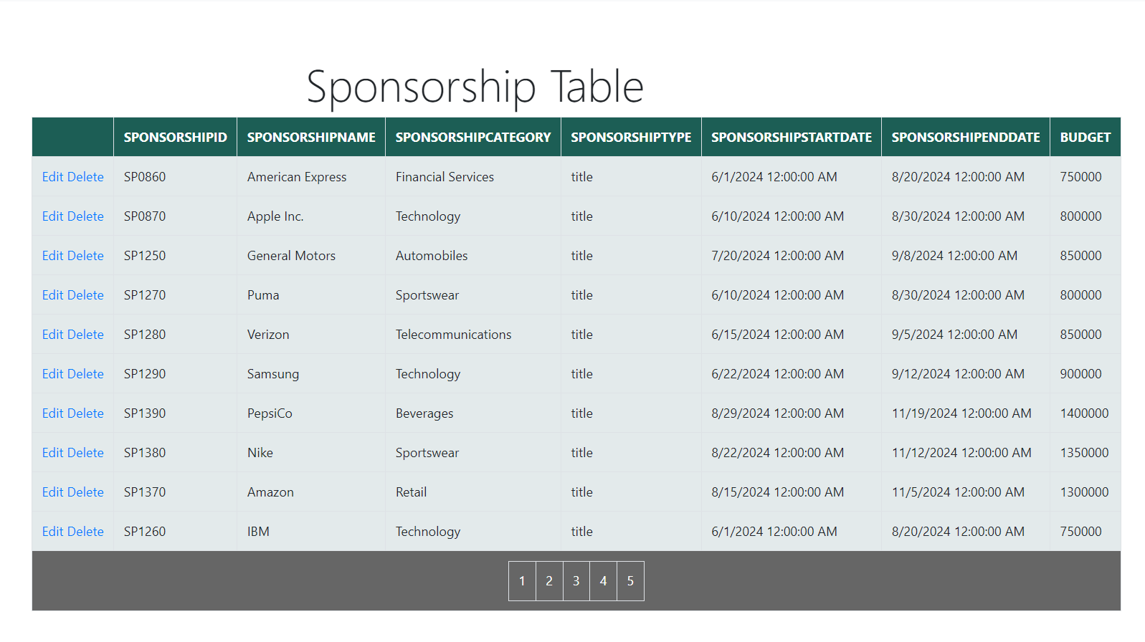

The second view is the **DETAILED VIEW**.

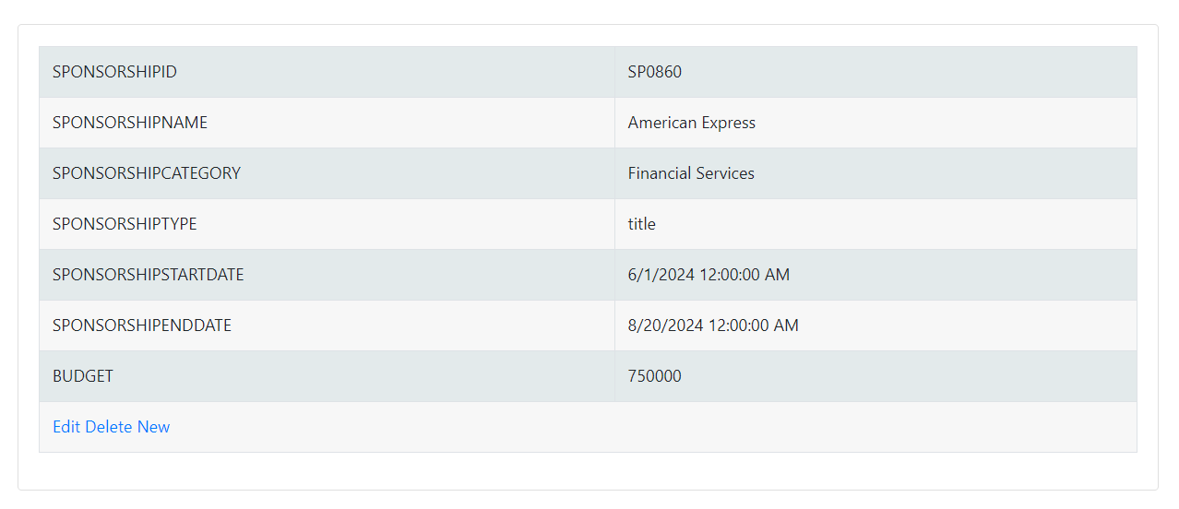

This view gave the option of inserting data in the tables along with deletion and update option. To insert new row of data in the table this form will be displayed on the UI.

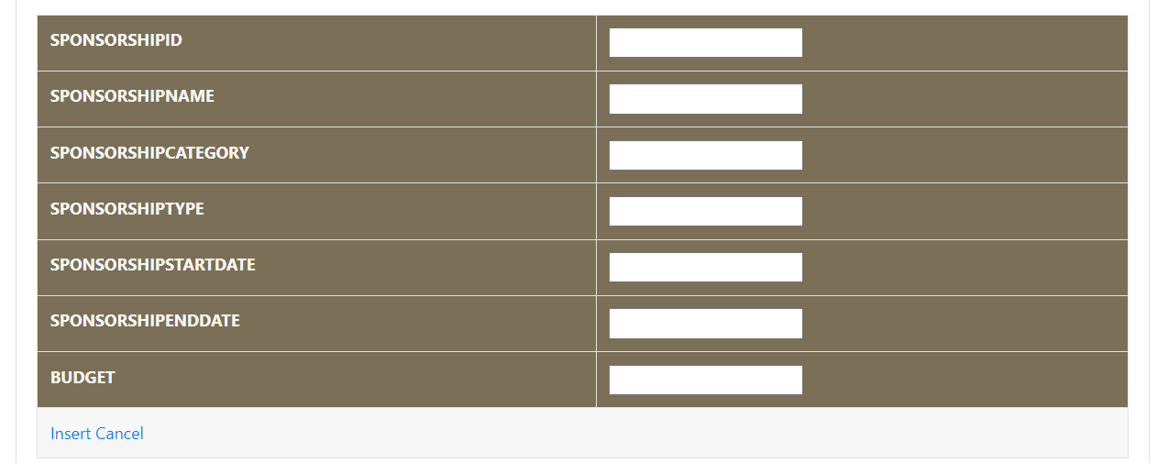

* 1. **events**

There are 2 kinds of views offered to the user, one of which is the **GRID VIEW**

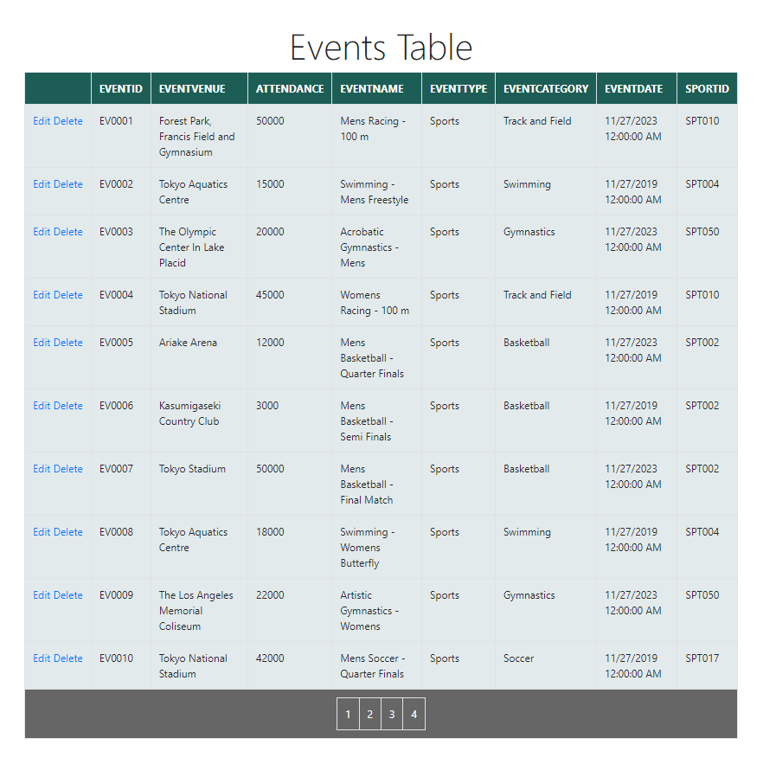

The second view is the **DETAILED VIEW.**

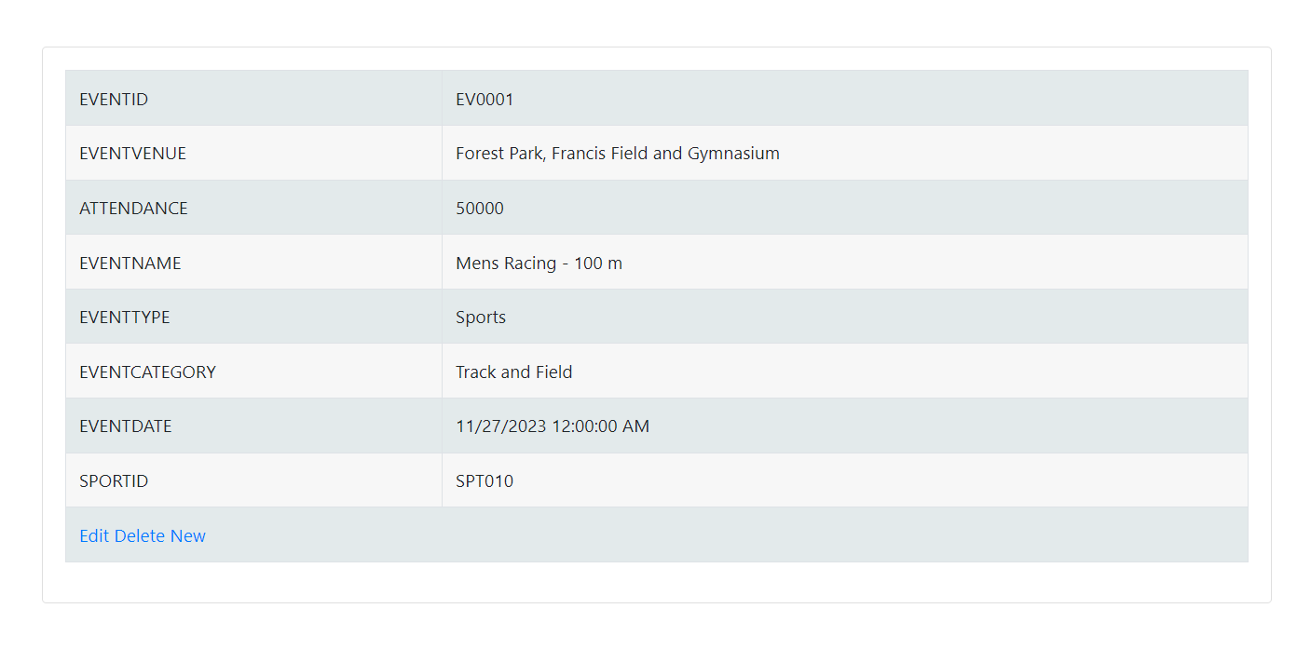

This view gave the option of inserting data in the tables along with deletion and update option. To insert new row of data in the table this form will be displayed on the UI.

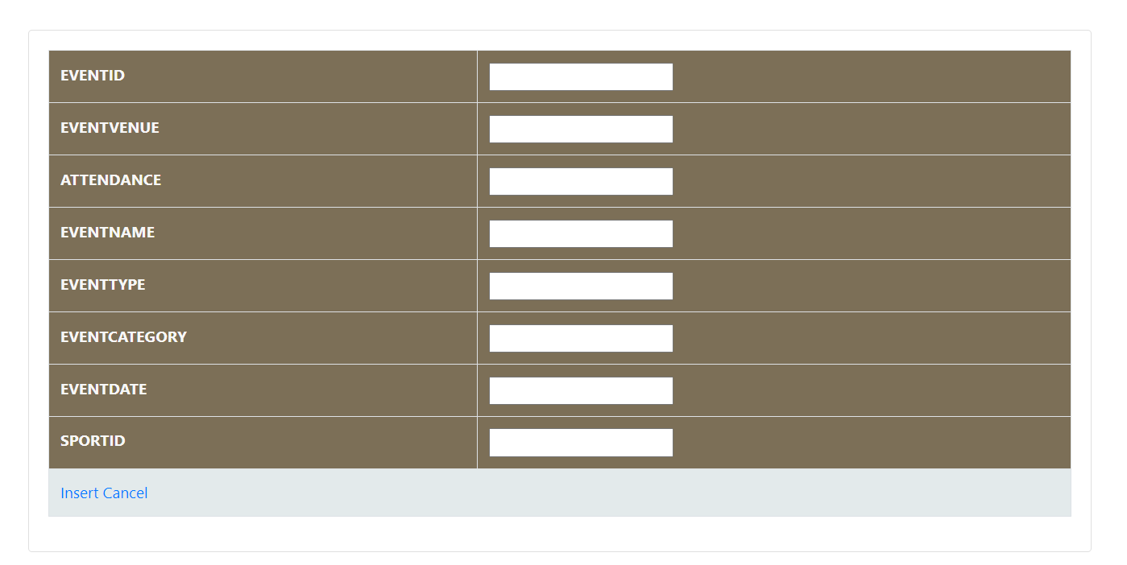

1. **INSIGHTS PAGE**

Like the tables menu page, the insights page contains links to the various query reports which we are terming as insights.

There are around 12 query reports that are derived from the structured and relational data in the database. Each report provides some insight into the data and each one of them as a specific use case of either business or intrinsic value.

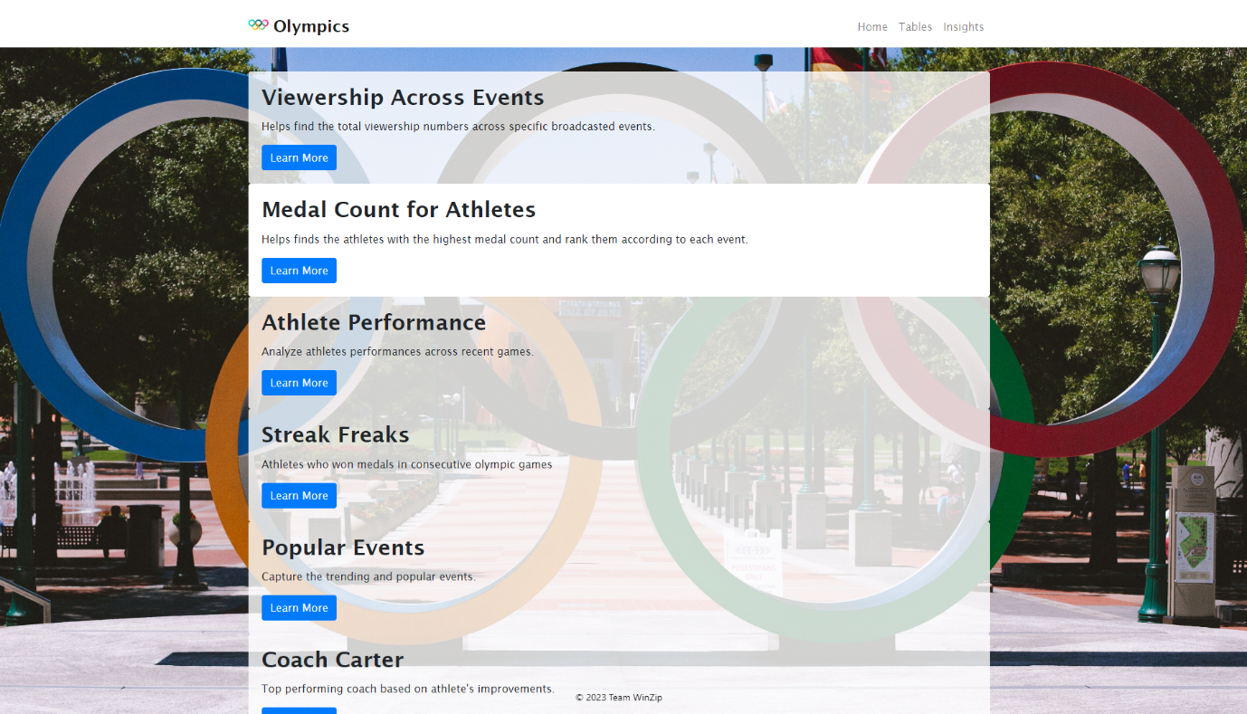

You can see the name of the report and a brief overview of it. We will now go over each report, and it’s result individually.

* + 1. **Viewership Across Events**

This query report helps find the total number of viewers across specific broadcasted events.

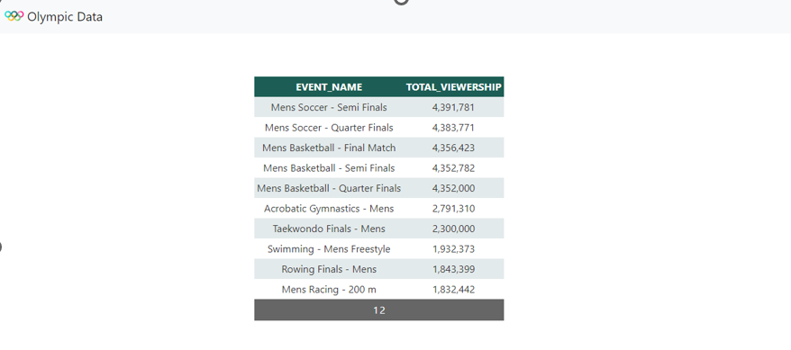

* + 1. **Medal Count for Athletes**

This query report helps find the total number of highest medal count and rank them according to each event.

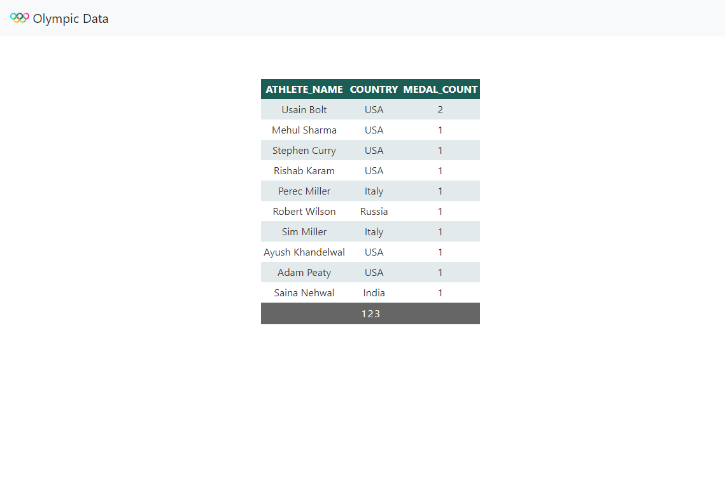

* + 1. **Athletes Performance**

This query report helps analyse athlete’s performances in recent Olympic Games.

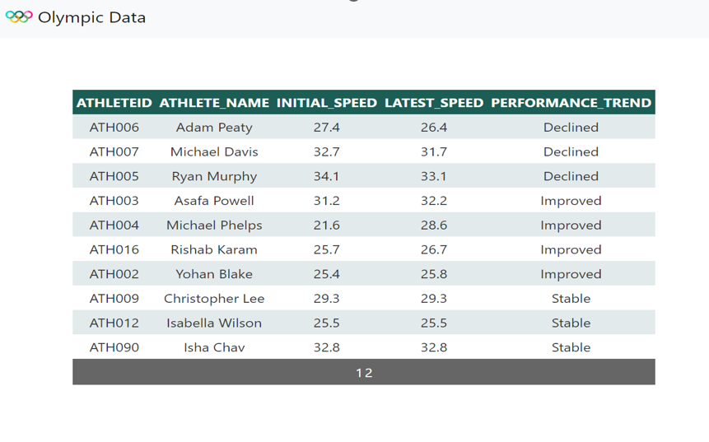

* + 1. **Streak Freaks**

This query report helps find the athletes who won medals in consecutive Olympic Games.

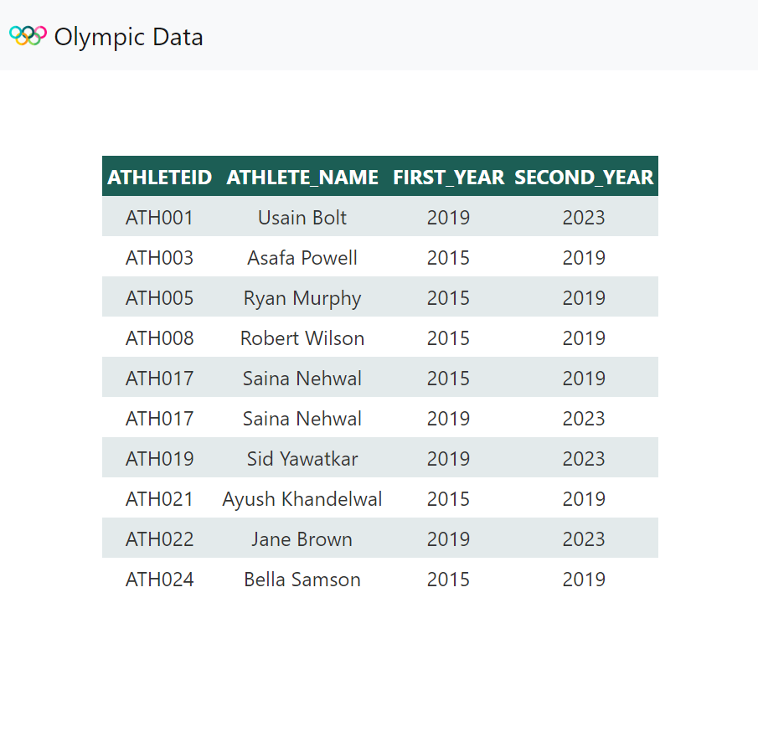

* + 1. **Popular Events**

This query report helps capture the most trending and popular events.

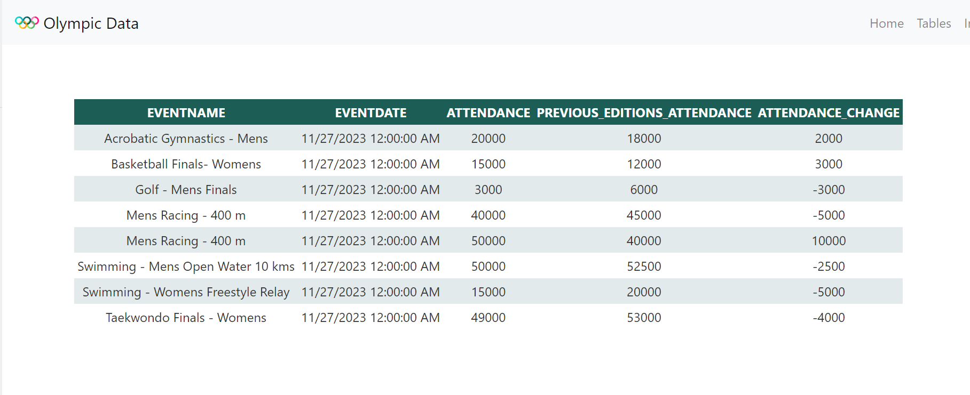

* + 1. **Coach Carter**

This query report helps to find the top performing coaches based on athlete’s improvements across the recent games.

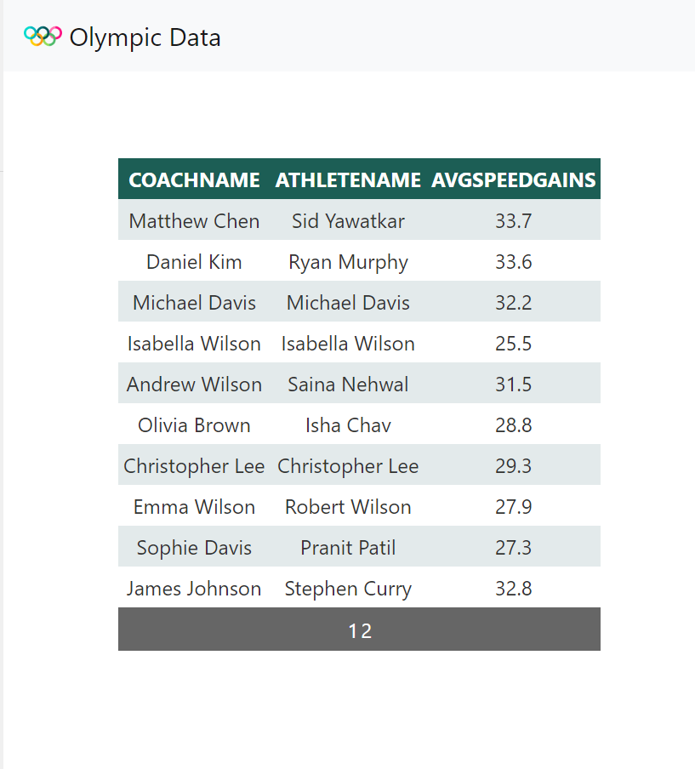

* + 1. **Doping**

This query report helps analyse the results of doping tests conducted for athletes.

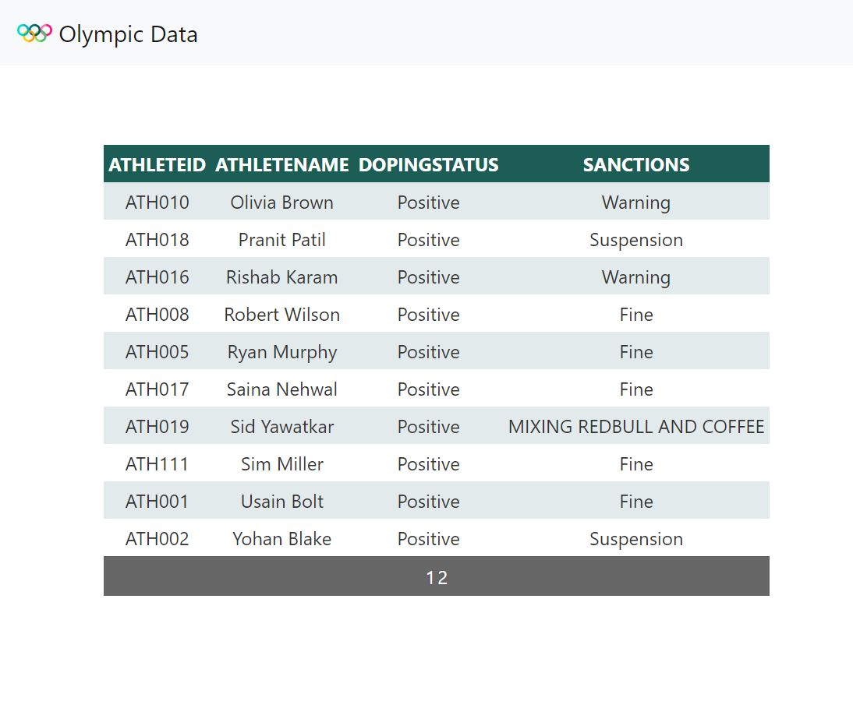

* + 1. **Sponsorships**

This query report lists out sponsorships details by events, as in which sponsored events have maximum viewership/visibility.

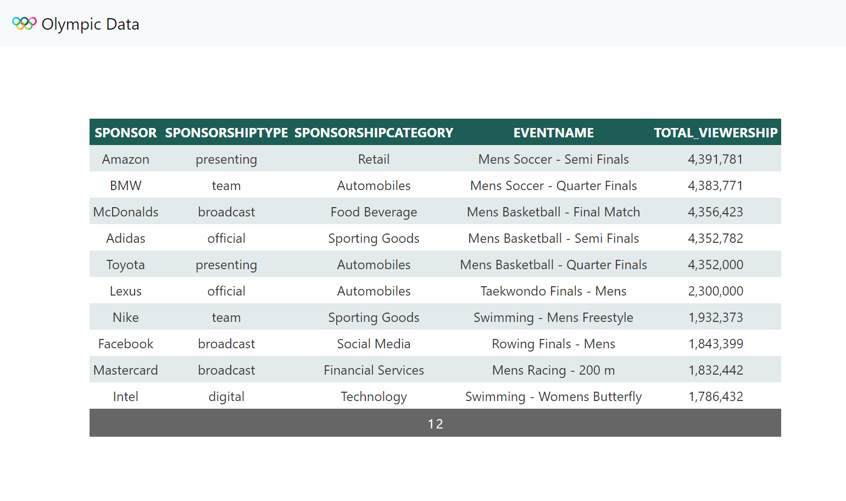

* + 1. **Viewership V/S Athletes**

This query report analyses the increase in viewership based on the athlete’s performance in a particular event.

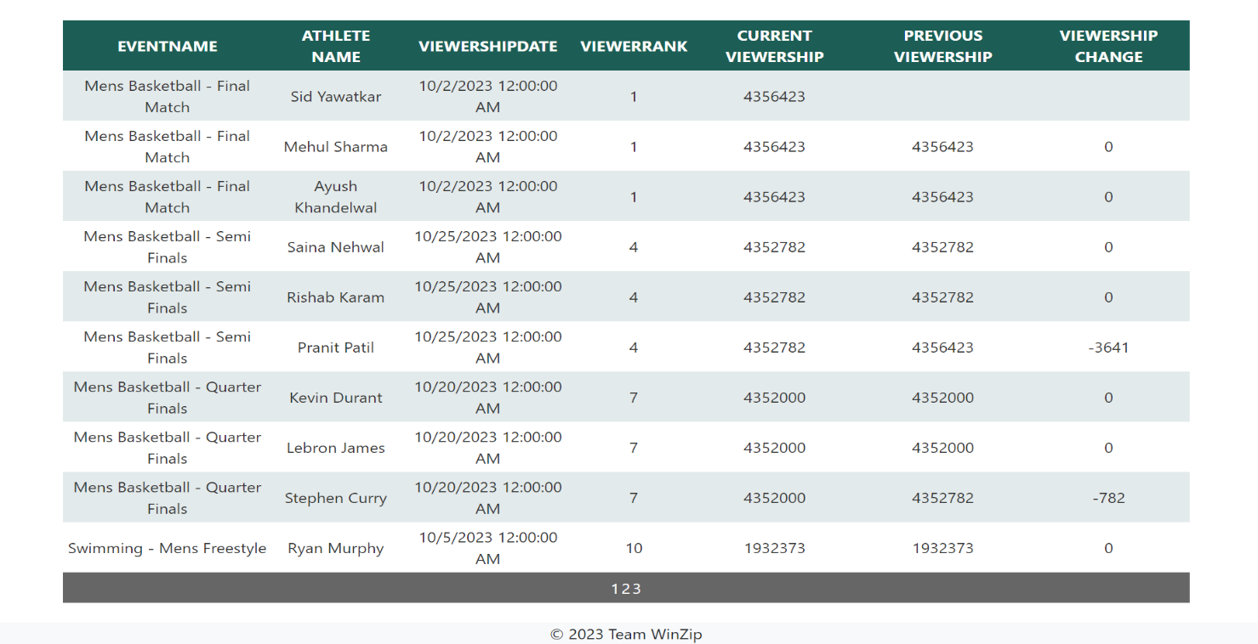

* + 1. **Broadcasters**

This query report helps uncover details about broadcasters and their viewership to draw insights.

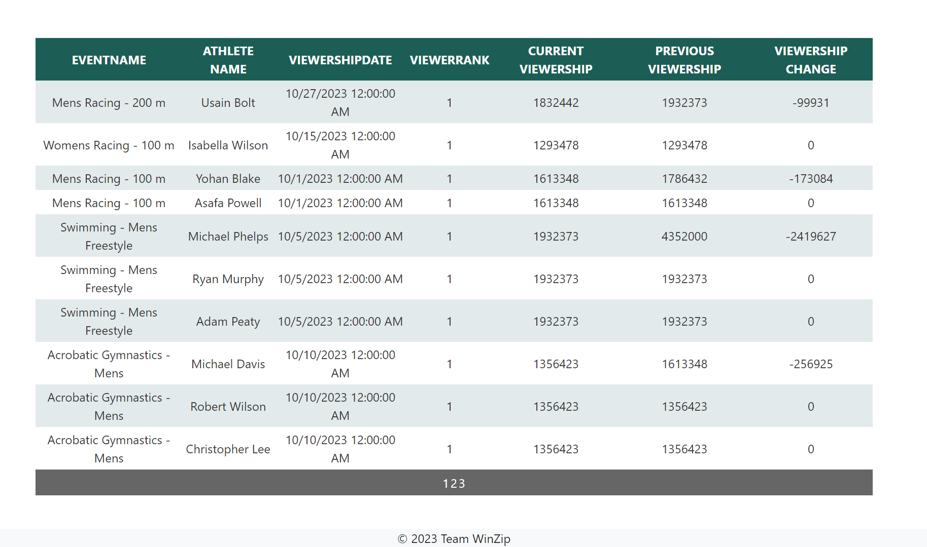

* + 1. **Streak Freak 2.0**

This query report helps identify athletes who participated in consecutive Olympic games.

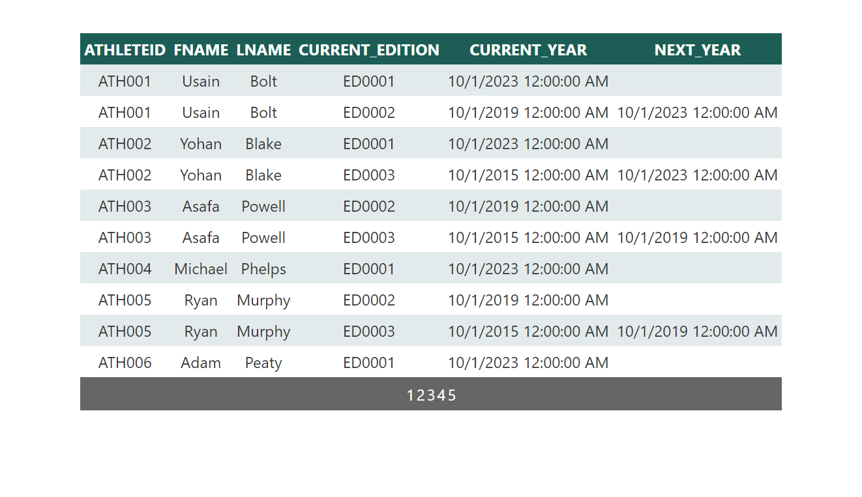

* + 1. **Jack of all trades**

This query report helps identify athletes who participated across multiple sporting events.

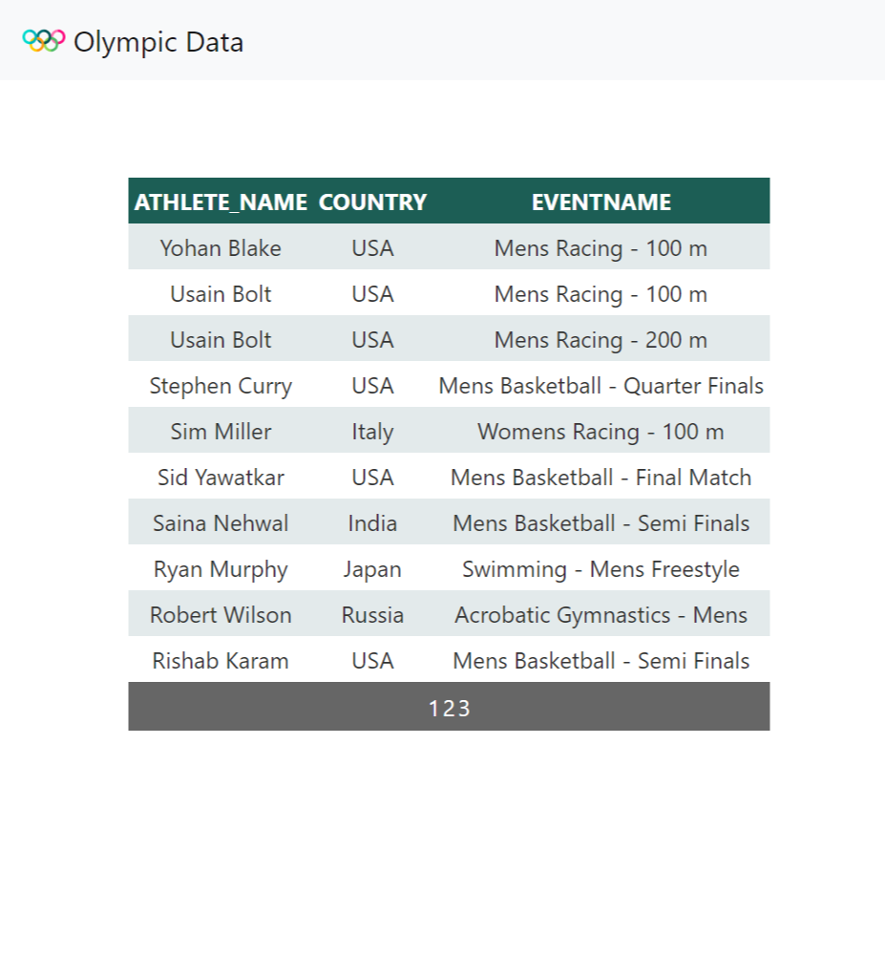

1. **HOME PAGE**

The home page is what you’ll see when you successfully login,

The purpose of home page is to include the credits to our project team, and a navbar to help user to around on the web application. A logout functionality is added to the application on the home page.

There’s a brilliant joke too, hahahahaha!

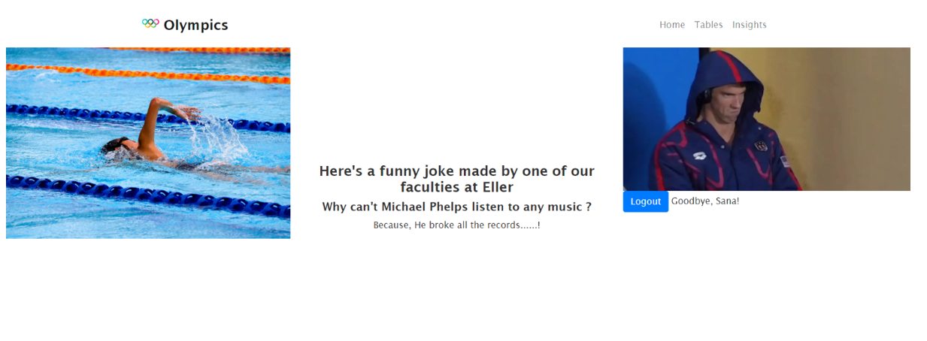

**Chapter 7**

## **7.1 Implementation Plan**

**1. Project Overview:**

* Scope: Full implementation of the Entity-Relationship Model of Olympics on a real-world database management system.
* Platform: AWS (Amazon Web Services) selected for implementation.

**2. Steps for Implementation:**

2.1 Database Setup

* Action Items:
* Create the necessary database schema based on the designed ER diagram.
* Set up tables, relationships, and constraints.
* Person-Hours Estimate: 20 hours
* Cost Estimate: AWS RDS (Relational Database Service) costs: $100

2.2 Backend Development

* Action Items:
* Develop backend logic to handle CRUD operations.
* Implement triggers and procedures in the database.
* Integrate backend with the chosen web development stack .NET.
* Person-Hours Estimate: 40 hours
* Cost Estimate:
* Developer salaries: $2,000
* Software licenses (.NET): $500

2.3 Frontend Development

* Action Items:
* Develop UI components for login, registration, tables menu, and insights pages.
* Ensure seamless integration with the backend for data retrieval and manipulation.
* Person-Hours Estimate: 30 hours
* Cost Estimate:
* Developer salaries: $1,500
* UI/UX design tools: $300

2.4 Security Implementation

* Action Items:
* Implement secure login mechanisms.
* Set up access controls and permissions for different user roles.
* Person-Hours Estimate: 15 hours
* Cost Estimate: Security tools/licenses: $200

2.5 Testing

* Action Items:
* Conduct unit testing for backend functions.
* Perform integration testing for the entire system.
* Test security features and access controls.
* Person-Hours Estimate: 25 hours
* Cost Estimate: Testing tools/licenses: $300

2.6 Deployment

* Action Items:
* Deploy the application on AWS EC2 instances.
* Configure the web server and ensure proper connectivity with the backend.
* Person-Hours Estimate: 10 hours
* Cost Estimate:
* AWS EC2 costs: $150
* Web server software licenses: $200

**3. Total Estimated Effort:**

* Person-Hours: 140 hours
* Cost Estimate: $5,250

1. **Visual Summary of Cost Breakdown:**

|  |  |  |
| --- | --- | --- |
| **Phase** | **Person-Hours** | **Cost Estimate** |
| Database Setup | 20 | $100 |
| Backend Development | 40 | $2,500 |
| Frontend Development | 30 | $1,800 |
| Security Implementation | 15 | $200 |
| Testing | 25 | $300 |
| Deployment | 10 | $350 |
| Total | 140 | $5,250 |

**5. References:**

* AWS Pricing: [AWS Pricing](https://aws.amazon.com/pricing/)
* Microsoft .NET: [Microsoft .NET](https://dotnet.microsoft.com/)
* UI/UX Design Tools: [Figma Official Website](https://www.figma.com/)
* Security Tools/Licenses: [Amazon Inspector](https://aws.amazon.com/inspector/)
* Testing Tools/Licenses: [Selenium](https://www.selenium.dev/)

## **Appendix A**

The EDM project has been a profound learning experience, encompassing an in-depth exploration of database management, as well as both frontend and backend development. From the initiation of requirements collection to the creation of tables and data insertion, we learned that the formulation of the Entity-Relationship (ER) diagram is pivotal in determining the database's quality. Following proper rules and options during ER creation ensures a relational design that eliminates the need for further normalization.

Understanding the critical role of translating ER into Relational Model in Database creation, we discovered that a well-structured database allows for efficient data storage and retrieval. The comprehensive nature of data enhances end-user insights through seamless query execution. Implementing constraints proved essential for maintaining database integrity, preventing the addition of values that deviate from requirements.

Designing a well-structured dataset becomes evident when queries reveal valuable insights. By employing various operations such as lead, lag, rank, and more, we successfully extracted meaningful insights, showcasing the robustness of our approach to data analysis. Incorporating triggers and procedures into our skill set, we realized their contribution to enhancing database functionality, automating tasks, and fortifying data integrity and overall system performance.

As we navigated the project's timeline, we grasped the importance of adhering to deadlines and maintaining a structured approach, thereby minimizing last-minute stress. Collaborative work dynamics became apparent during group tasks, teaching us effective problem resolution without escalating conflicts. Hosting the project on the web exposed us to diverse platforms/tools like AWS EC2, .NET, C#, and HTML, CSS, BootStrap. Despite encountering challenges during deployment, we developed a systematic approach to address each issue, learning about inbound/outbound rules and firewall setup in the process.

Observing other groups provided valuable insights, emphasizing the significance of going the extra mile to enhance project outcomes. The art of presentation, organizing complex information within a concise timeframe, was another crucial lesson learned. Effectively condensing months of work into a 10-minute presentation proved instrumental in conveying our achievements to the audience.

In summary, the EDM project not only honed our technical skills but also instilled valuable lessons in project management, teamwork, and effective communication, contributing to a holistic learning experience.